EX NO:01
DATE:

STARBUCKS SALES AND MARKETING ANALYSIS

AIM:
Problem Statement: Coffee Chain Sales and Marketing analysis, you are a Data Analyst working for Starbucks. The company is trying to assess marketing strategy effectiveness and sales distribution across various products they sell. You have been supplied with three data sets one for location, products and sales details in different format, and management has asked to show the following:

- Sales trend across two product categories, tea and coffee.

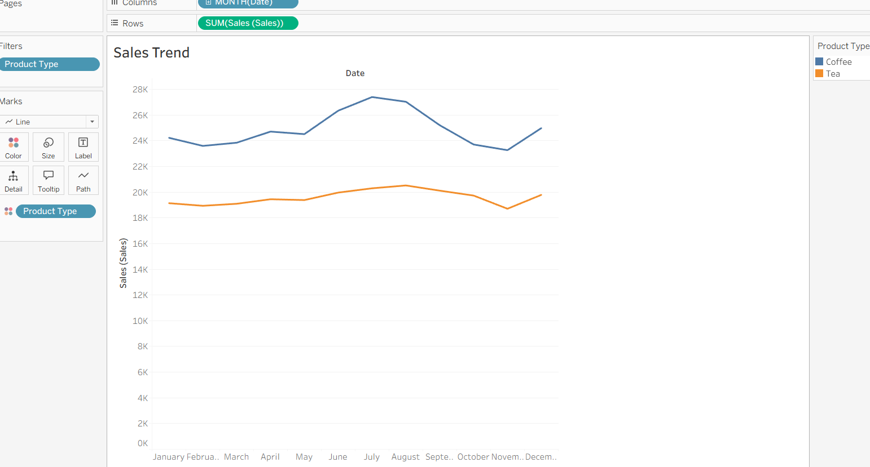

- Using Pie chart, show total sales distribution across product categories.

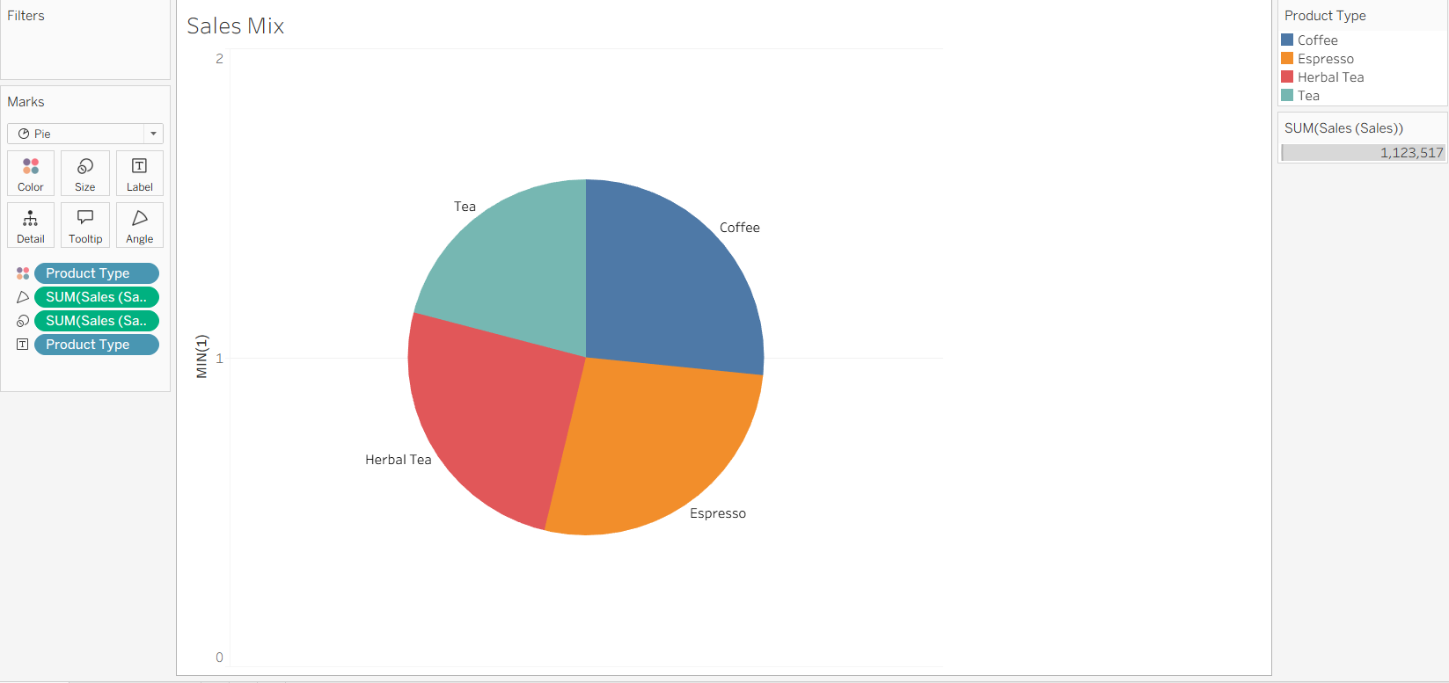

- Is there any correlation between Sales and Marketing Expenses? Any changes within the years? Build a scatter plot.

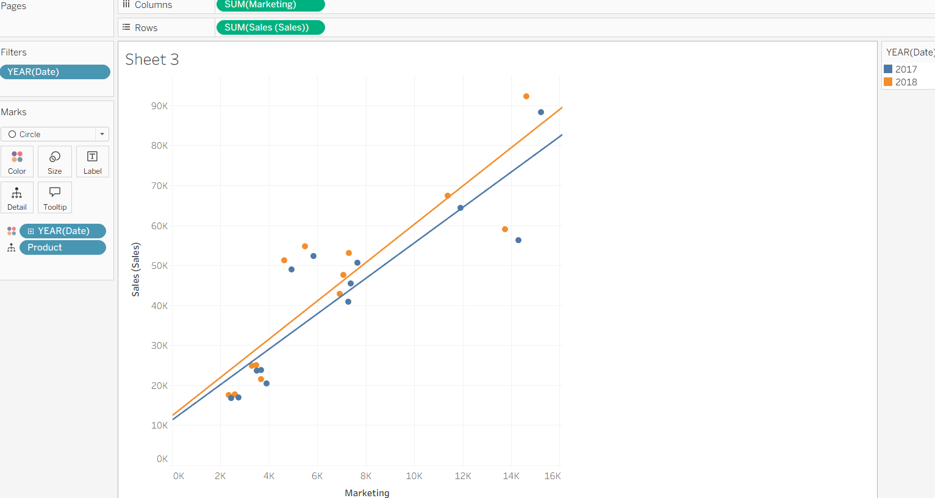

EX NO:02
DATE:
EL HORNO'S PIZZA BI ANALYSIS

AIM:
Problem Statement: You have been hired as a BI Analyst by El Horno’s Pizza. The company is trying to assess marketing strategy effectiveness and sales distribution across different products. The Director of the company has asked you to show the following:

- Sales trend across 2 product categories, Pizza and Burger. Build an Area Chart.

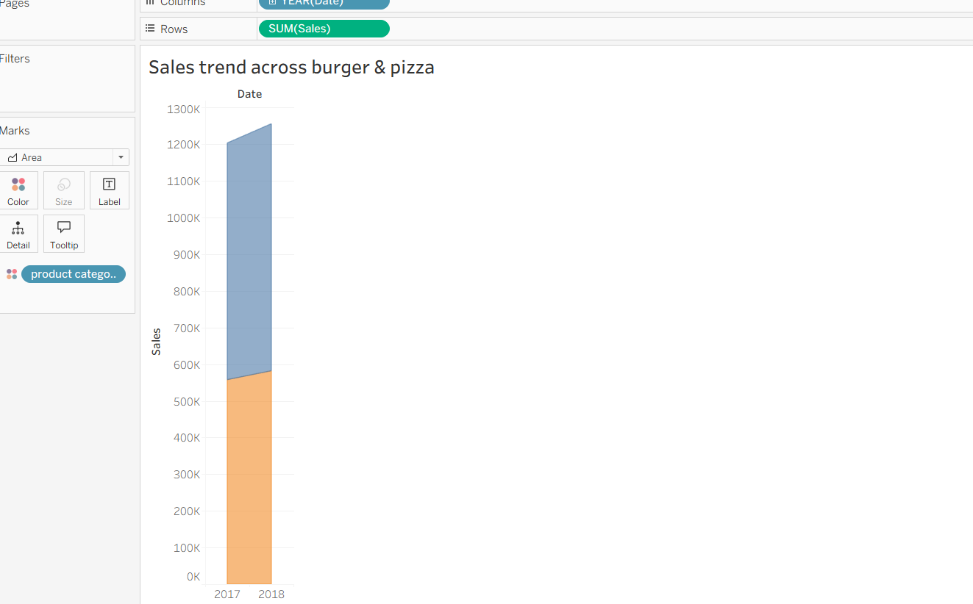

- A Pie Chart and display Total Sales Distribution across product categories.

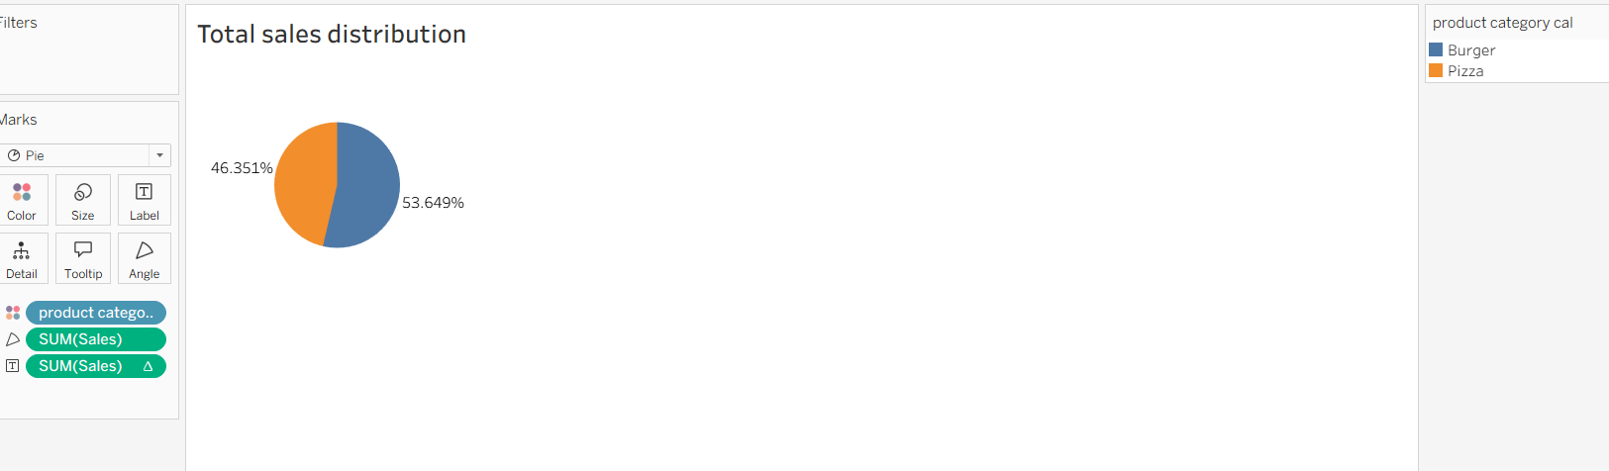
- Sales distribution across product categories. Show a Chart by States which indicates the percentage of Pizza category sales across total sales.
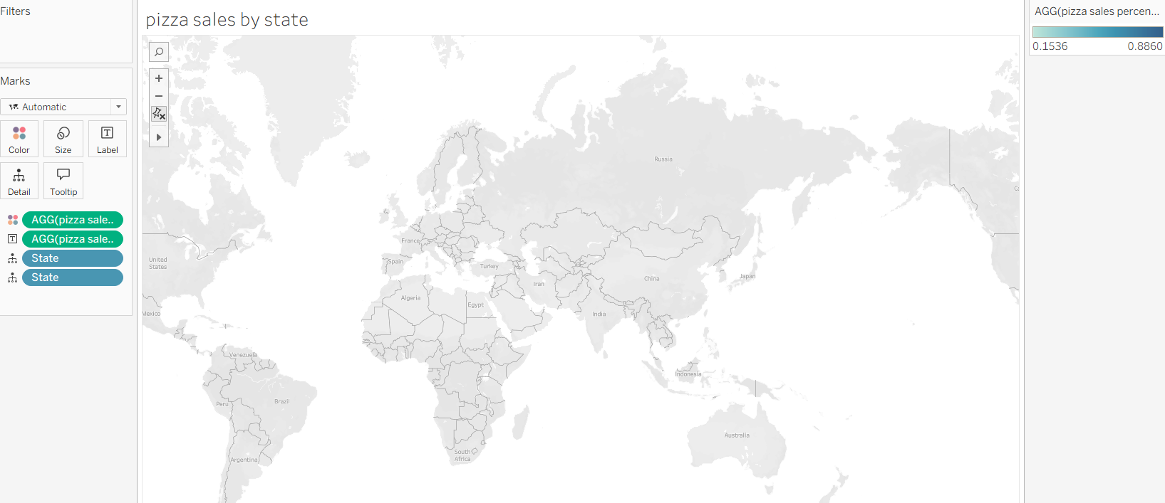
- Sales distribution across product categories. Show a Chart by states which indicates the percentage of Burger category sales across total sales.
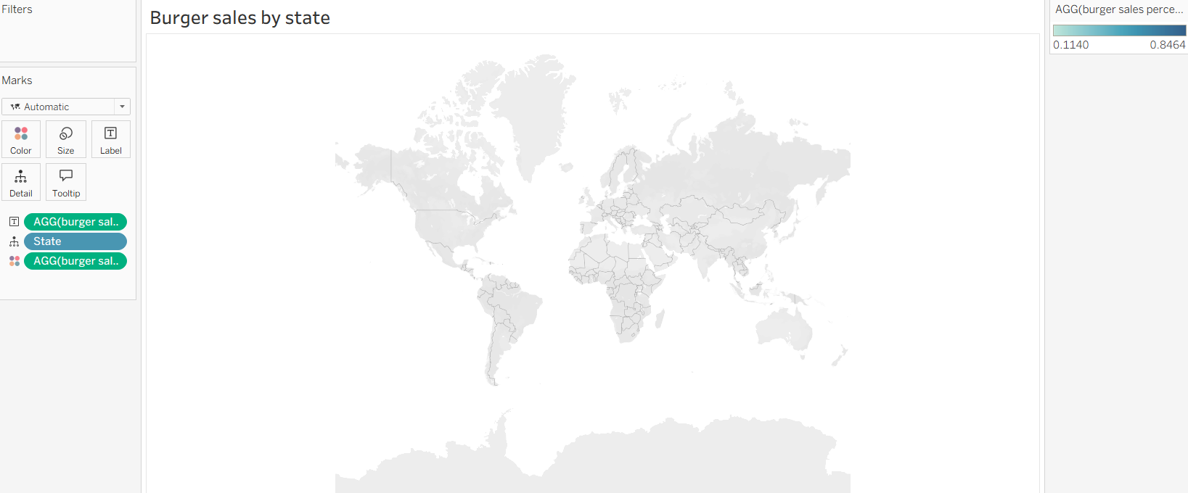

- Identify the States, wherein the marketing campaigns are most effective and which of the marketing teams need to revise their tools? Show this on Vertical bar chart.
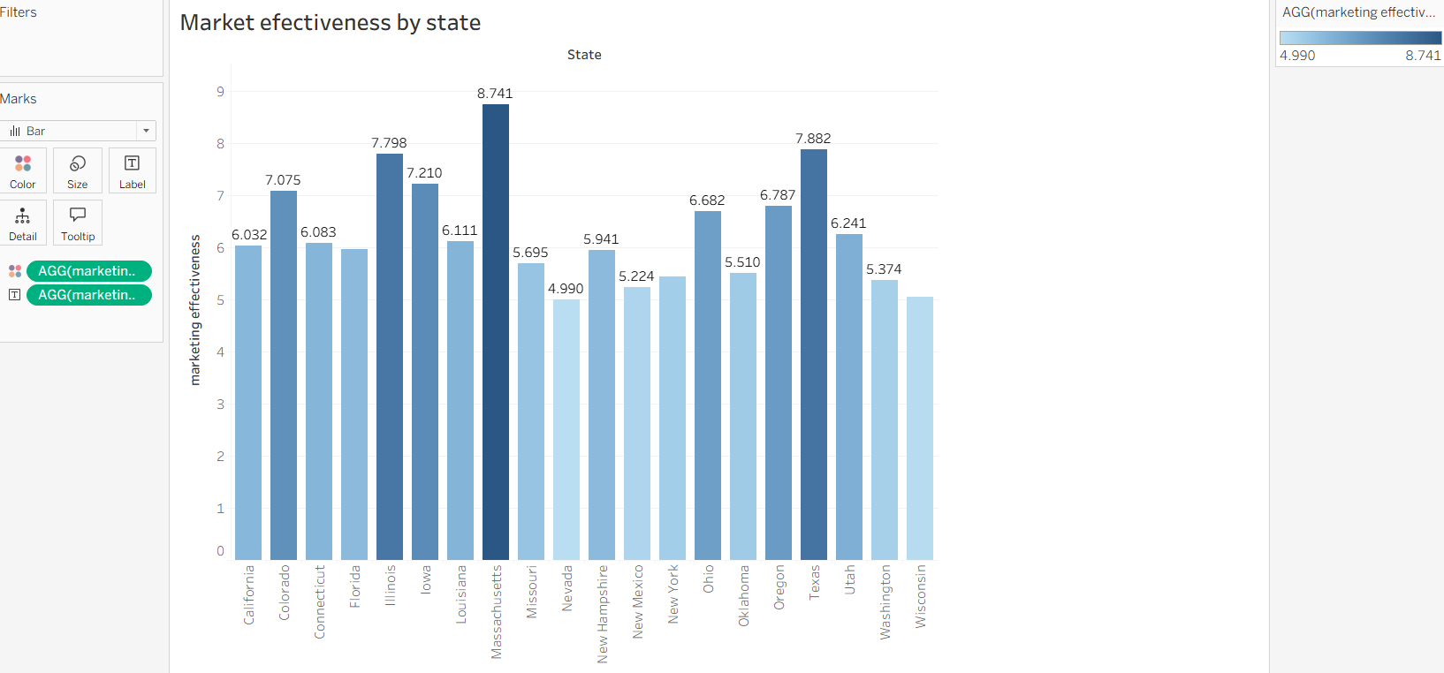
- A Scatter Plot and identify for correlation between Sales and Marketing Expenses, if any. Through Highlighting feature, identify for any changes within the years.

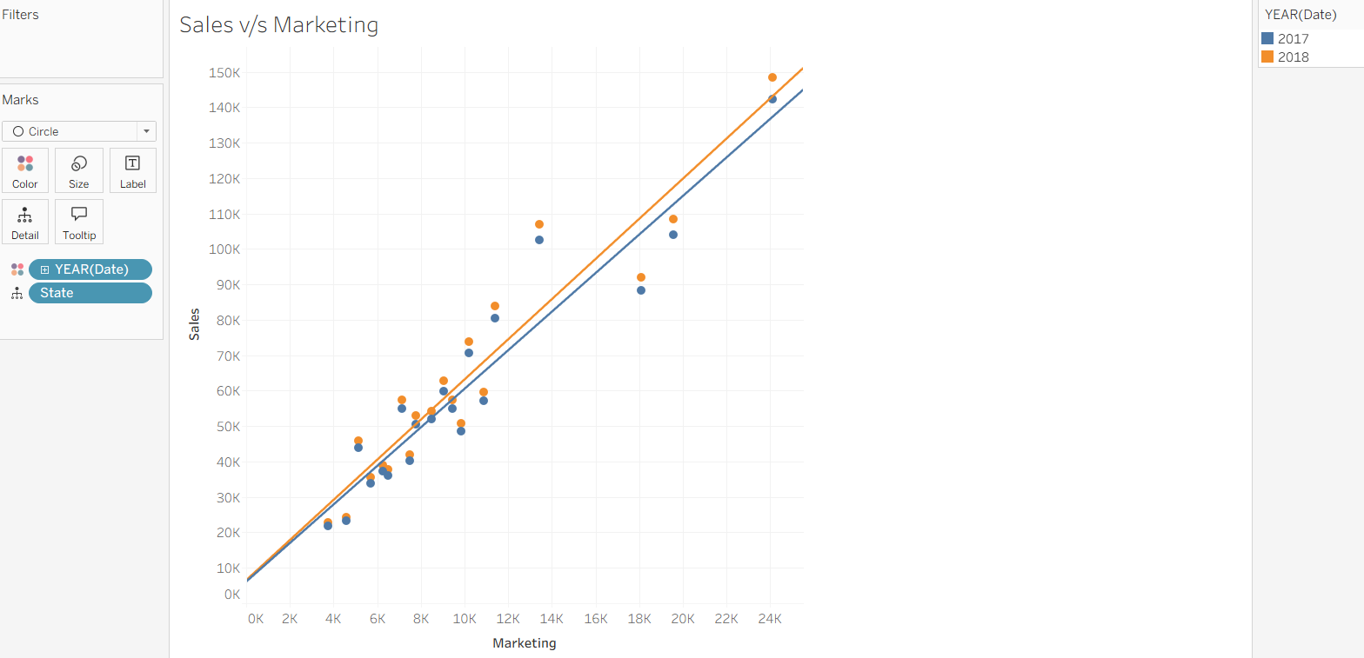

EX NO:03
DATE:

GLOBAL SUPERSTORE CHART CREATION

AIM:

- Draw a Pareto Chart for Running total of sum of profit. Use the dataset global superstore 2016

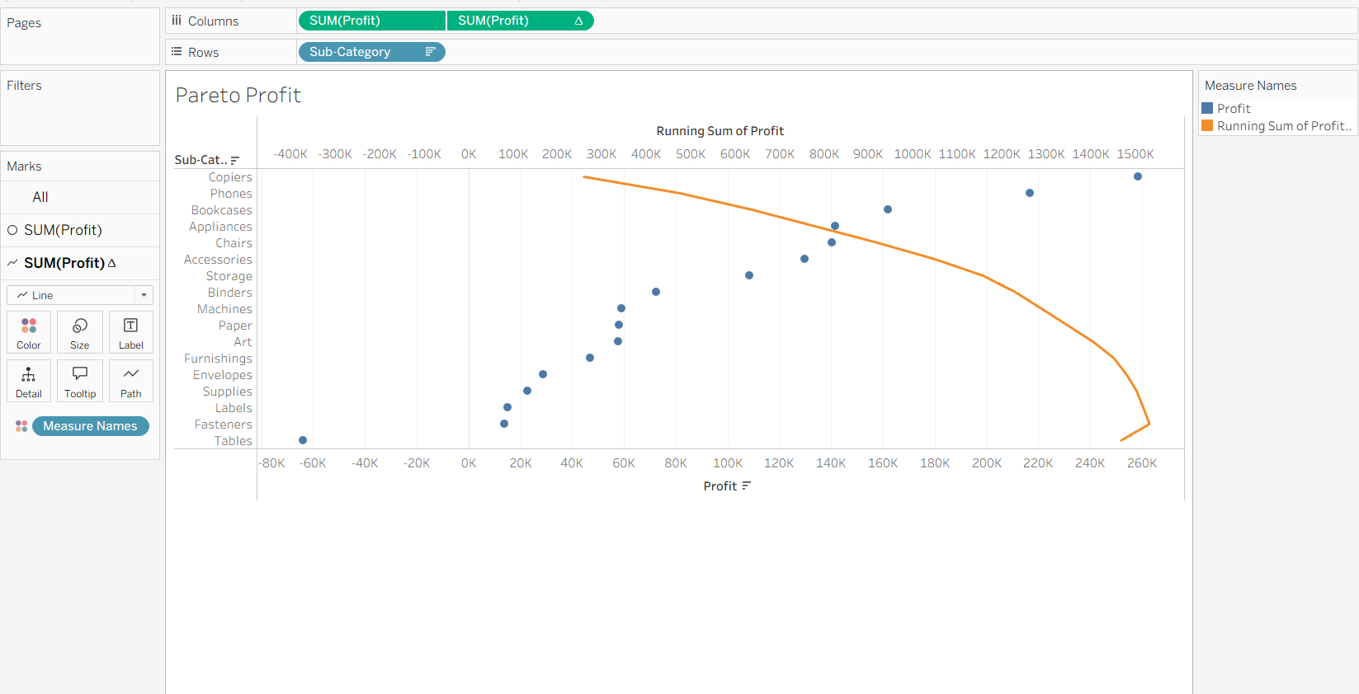

- How funnel chart shows the amount of potential revenue for each stage? – Discuss briefly. Use the dataset global superstore 2016

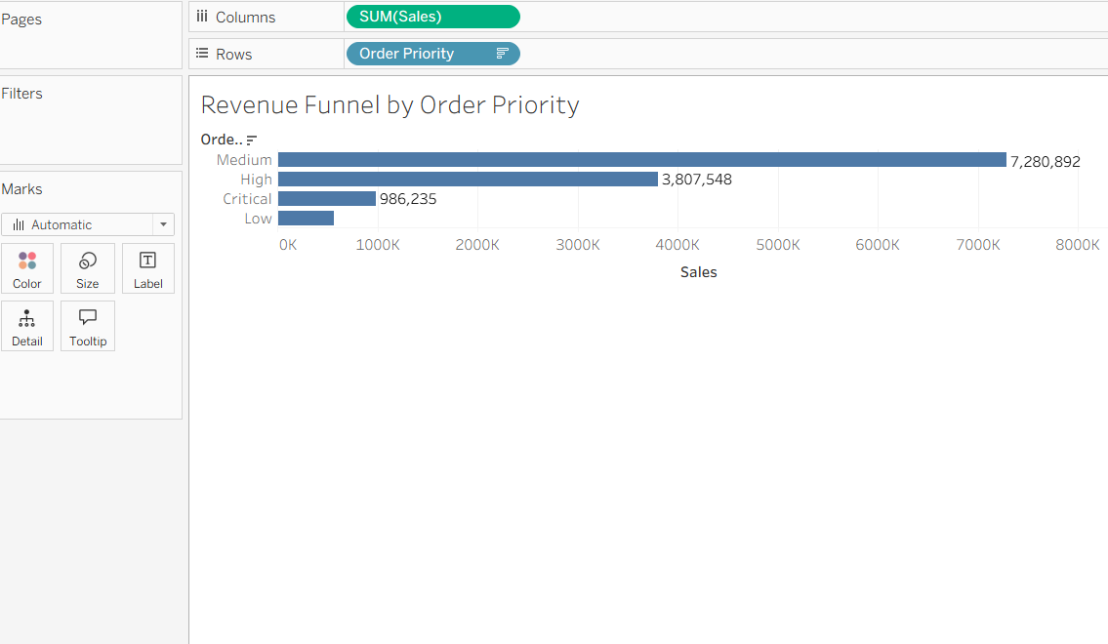

- Draw a Waterfall Chart show how the sales start, end and gets incremented over a period of time. Use the dataset global superstore 2016

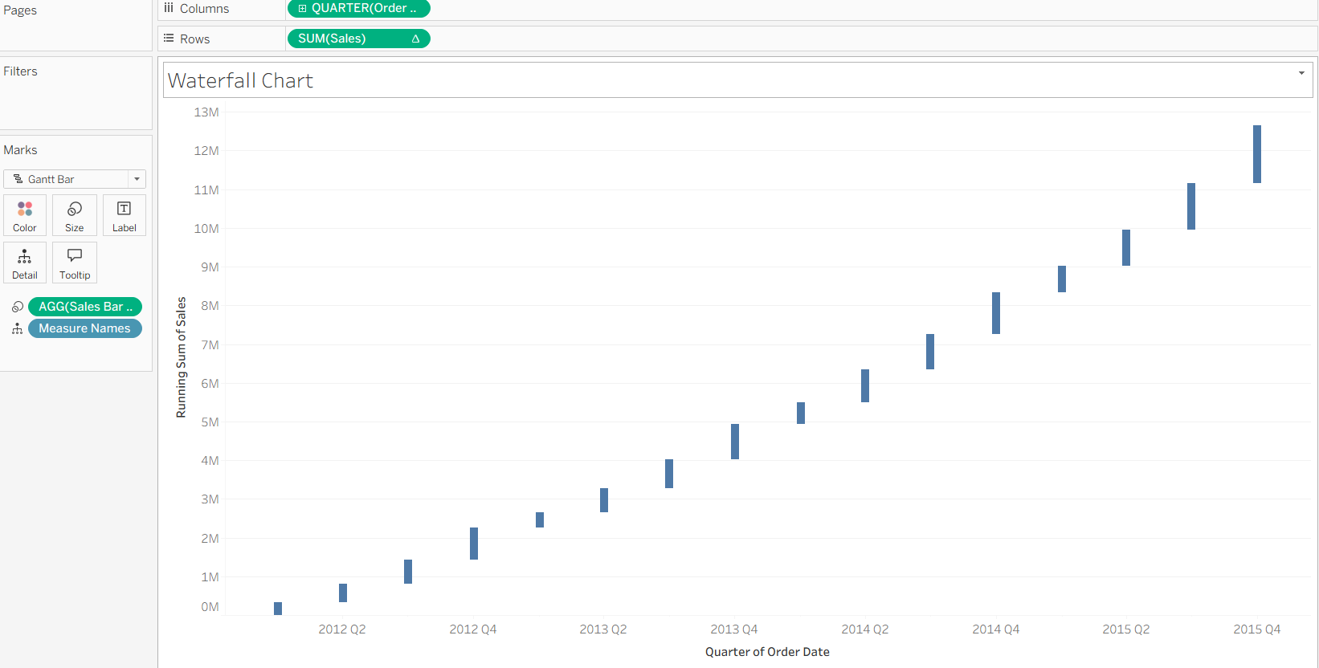

- Creates a control chart and sets up a parameter to determine control limits. Use the dataset global superstore 2016

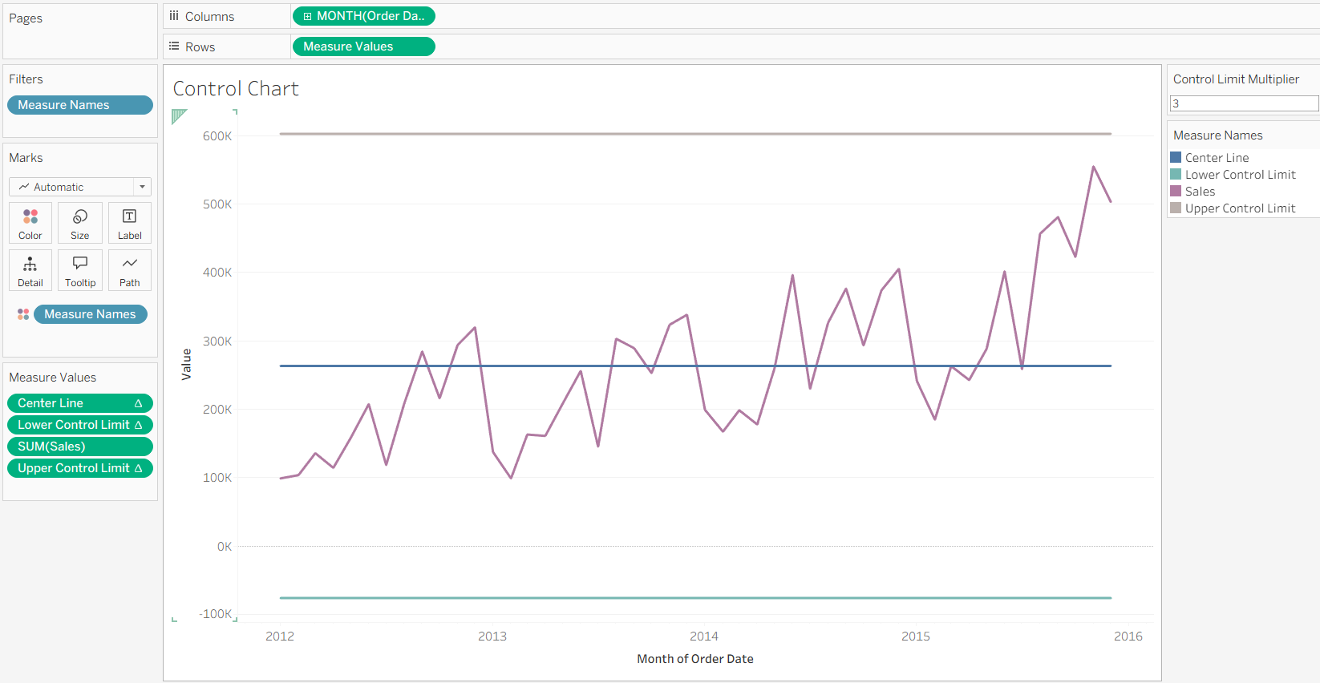

EX NO:04
DATE:
UK BANK DATA ANALYSIS

AIM:
Problem Statement: You have been hired by a Bank that is currently operating in United Kingdom. The bank has asked you to help them to ease the process of analyzing its data. The management has provided with a few queries for you to solve.

- Create a Map chart showing the number of transactions processed in each region.
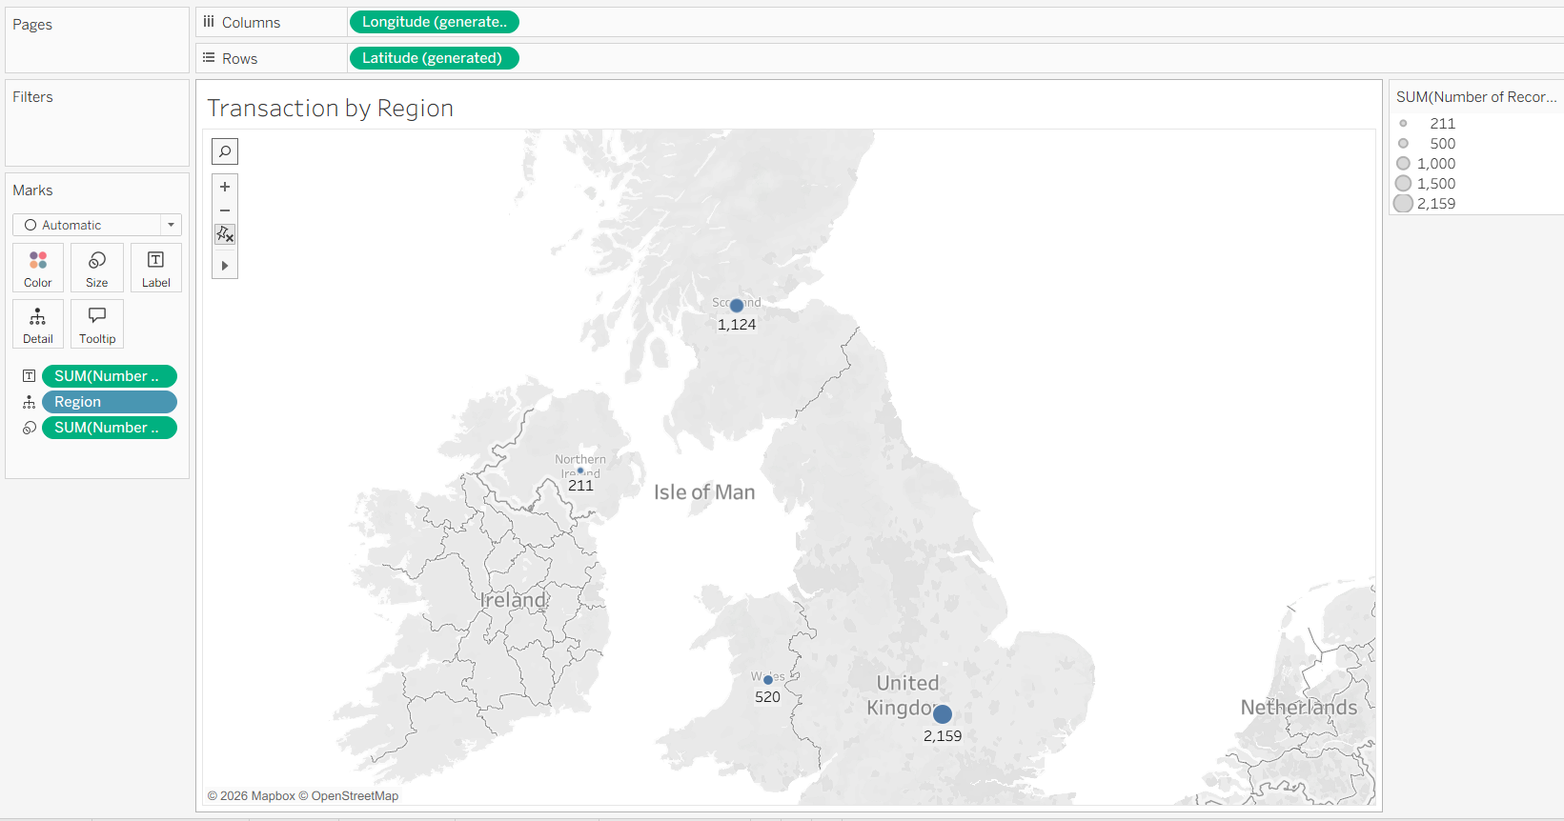
- Create a Pie chart displaying the percentage of each transaction processed between genders.

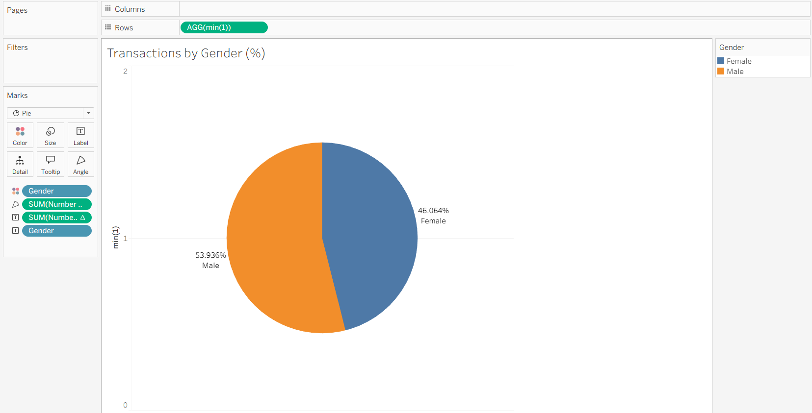
- Create a Histogram displaying the distribution of age and transactions processed.
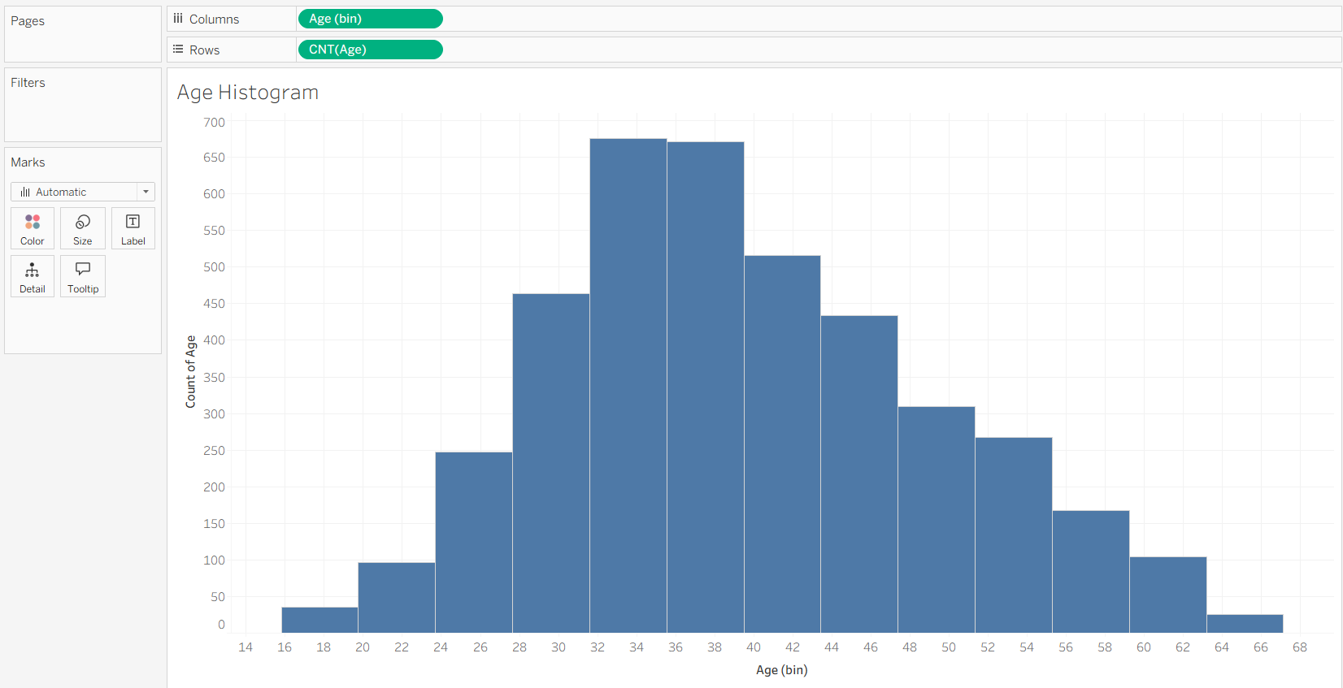
- Create a Histogram displaying the distribution of balance and transactions processed.
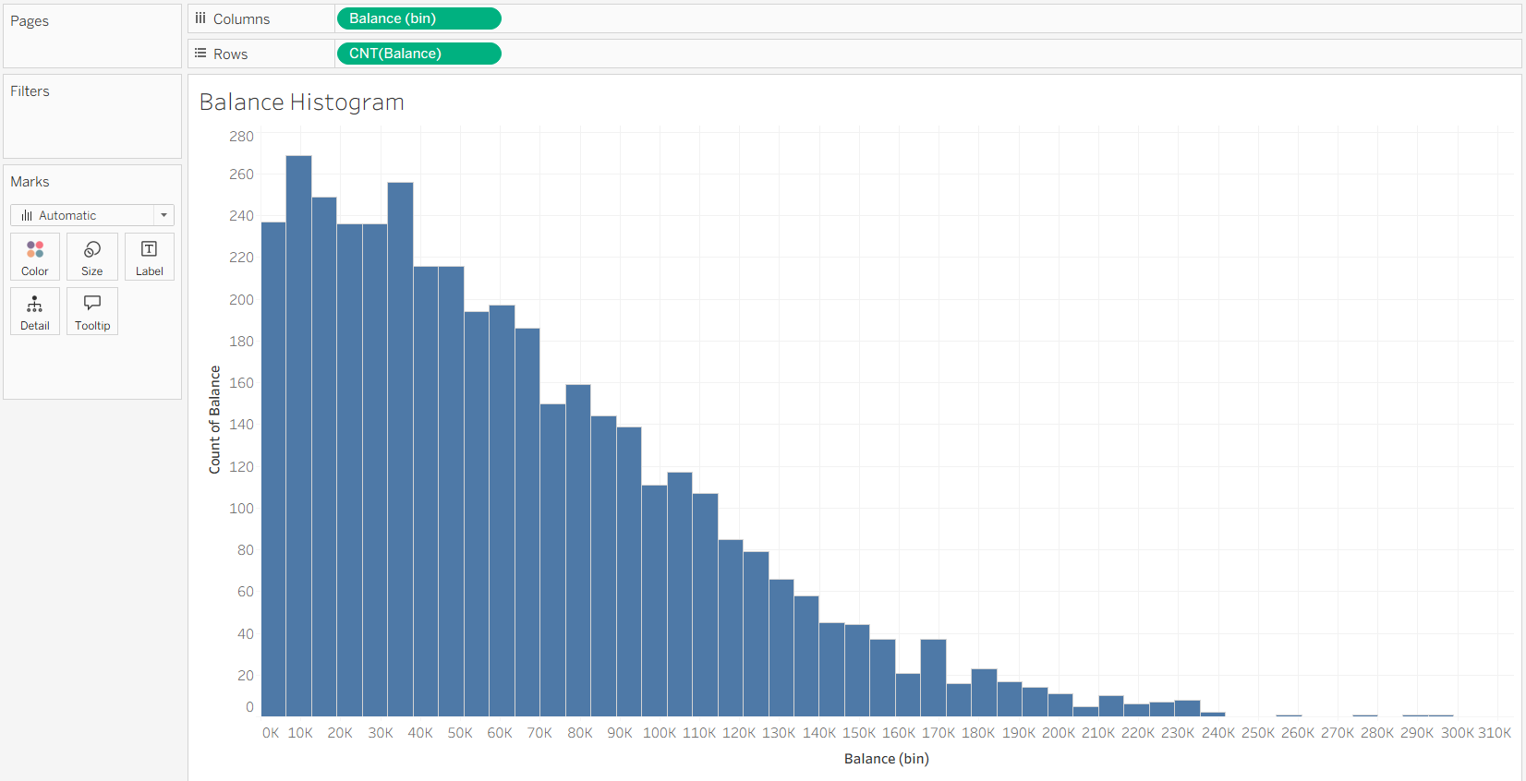
- Create a Tree-map displaying the number of transactions processed within the classification of each job.
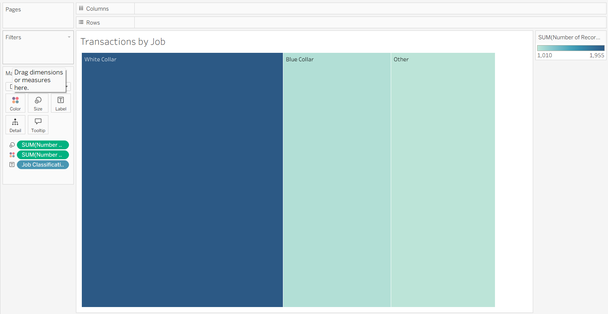

Create a Dashboard using all the charts. Make use of Action Filters as it will further improve the analyzing experience for the management. (Refer to the dataset from the file:UK BANK DATA.csv)
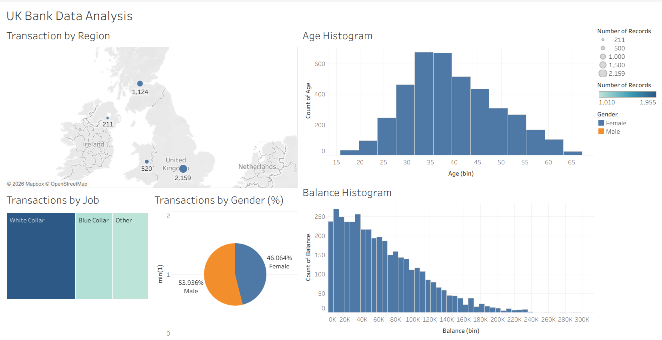

EX NO:05
DATE:

AIM:

EDUREKA INTERACTIVE DASHBOARD CREATION

Create an Interactive dashboard for Edureka’s most popular courses available in the dataset, by adding various forms of objects to it. (Data set: Edureka)
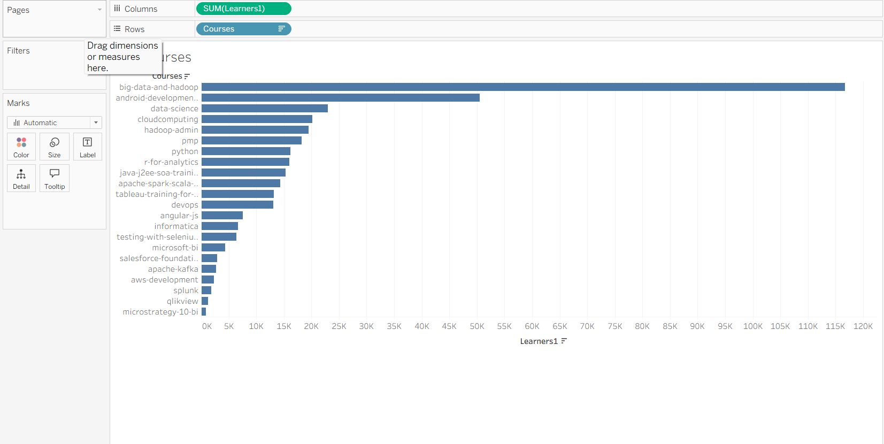

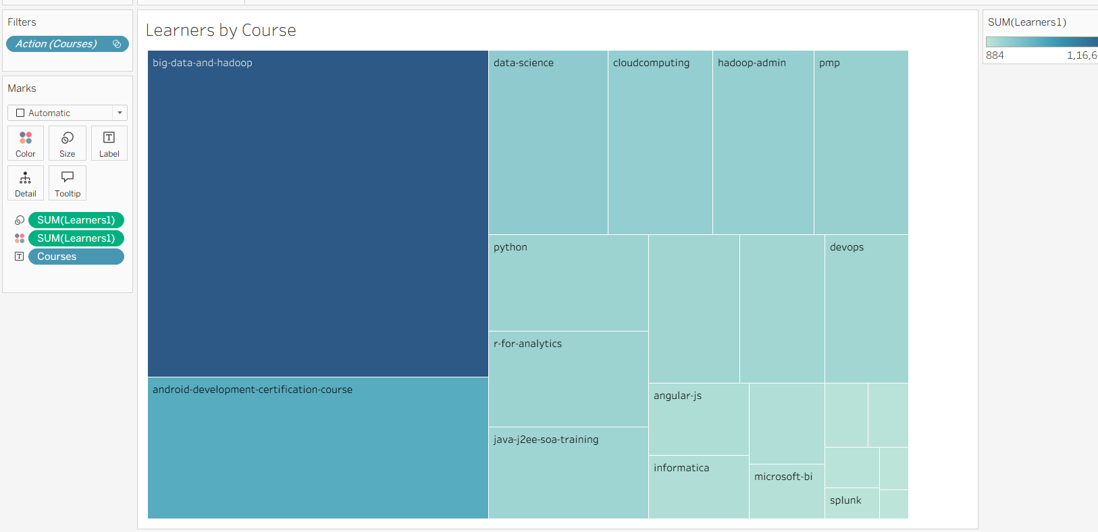

EX NO:06
DATE:
HALLOWEEN EVENT PLANNING DASHBOARD

AIM:
This Dashboard explains the evaluation of the individuals who participate in Halloween activities. It is used to understand the event planning. The following information we can get from this dashboard.

- Find the precipitation level
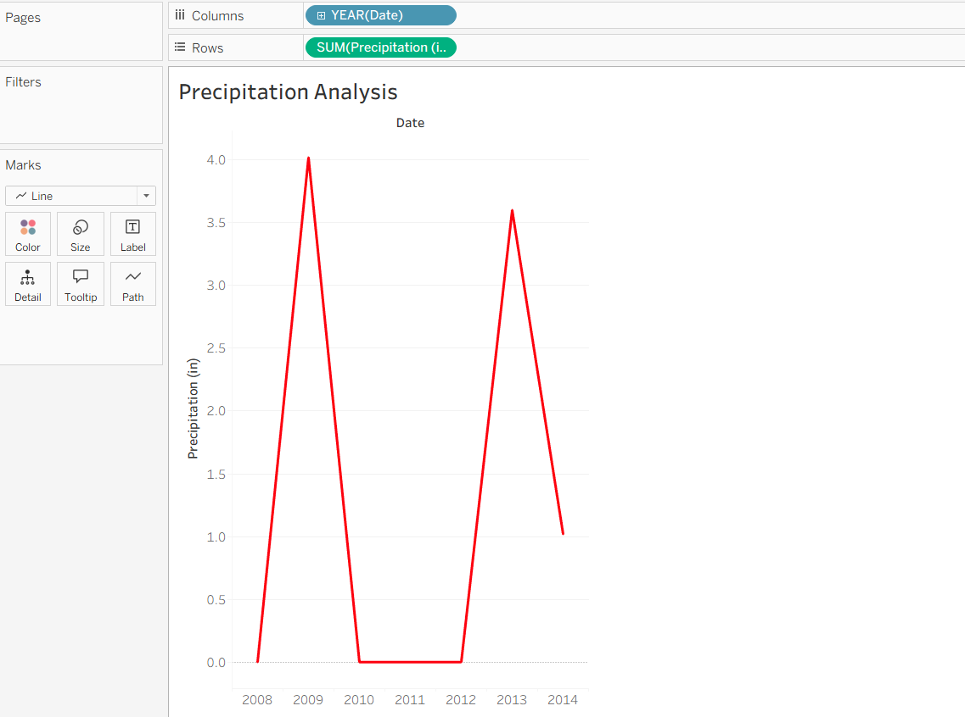

- Forecast the future event
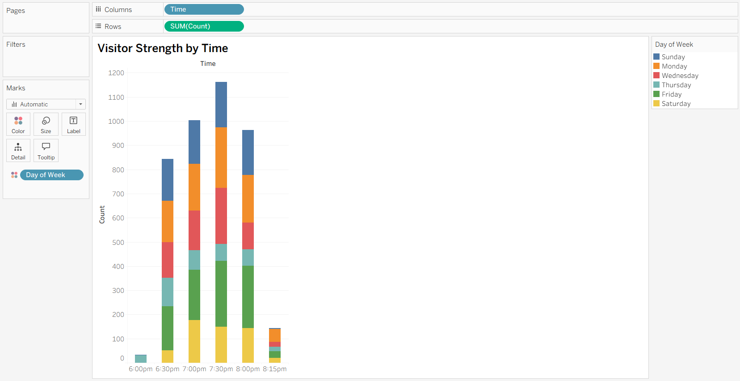

- Show year by year variation
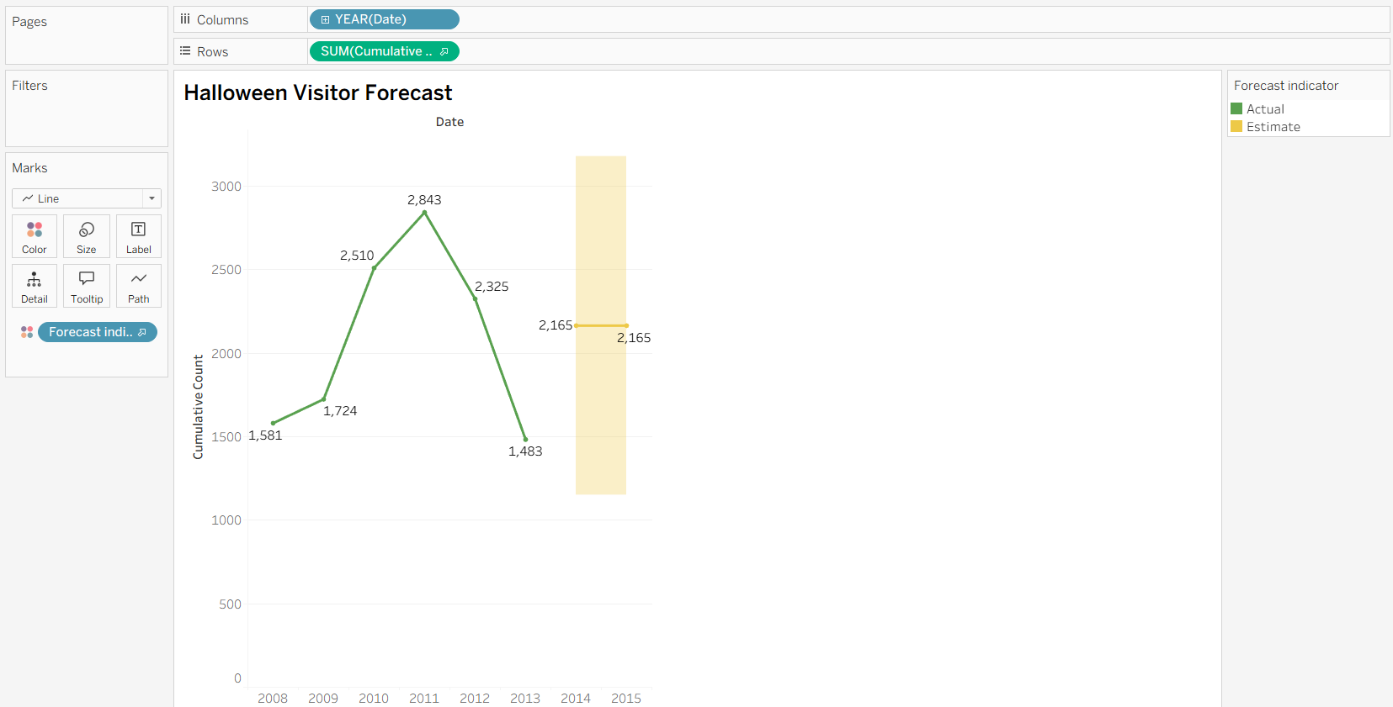

- Display visitor strength

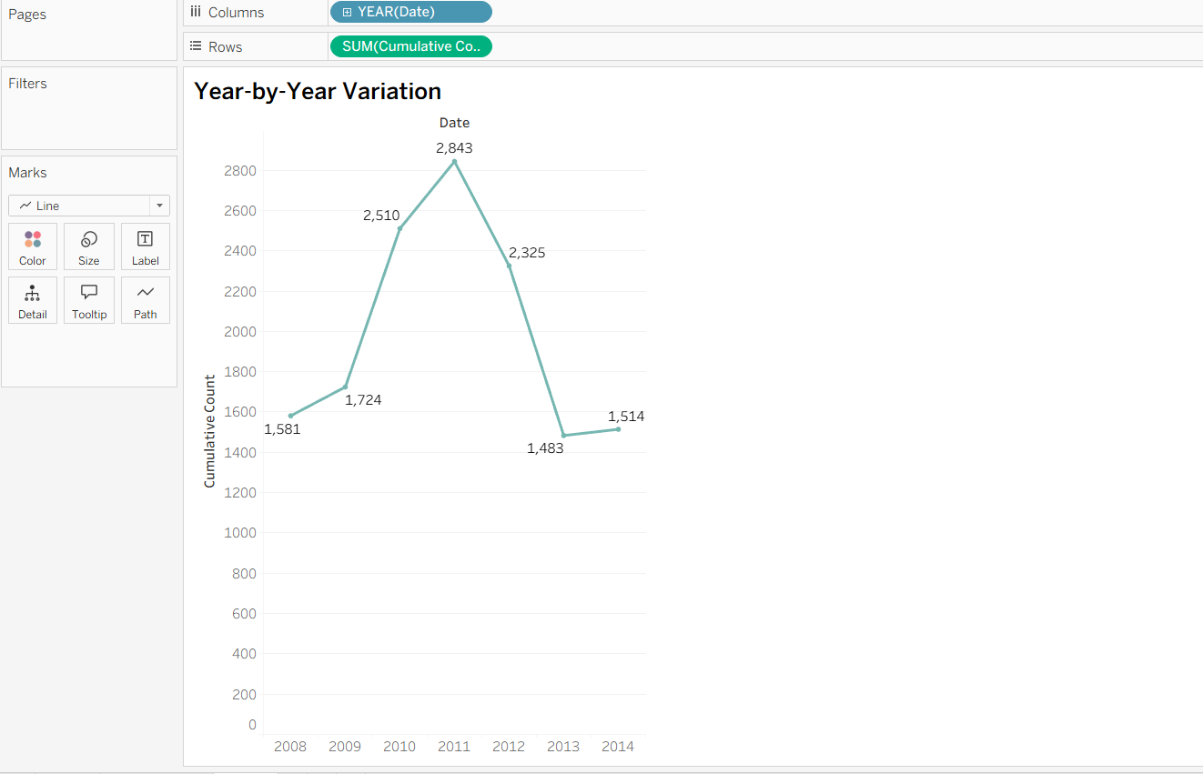

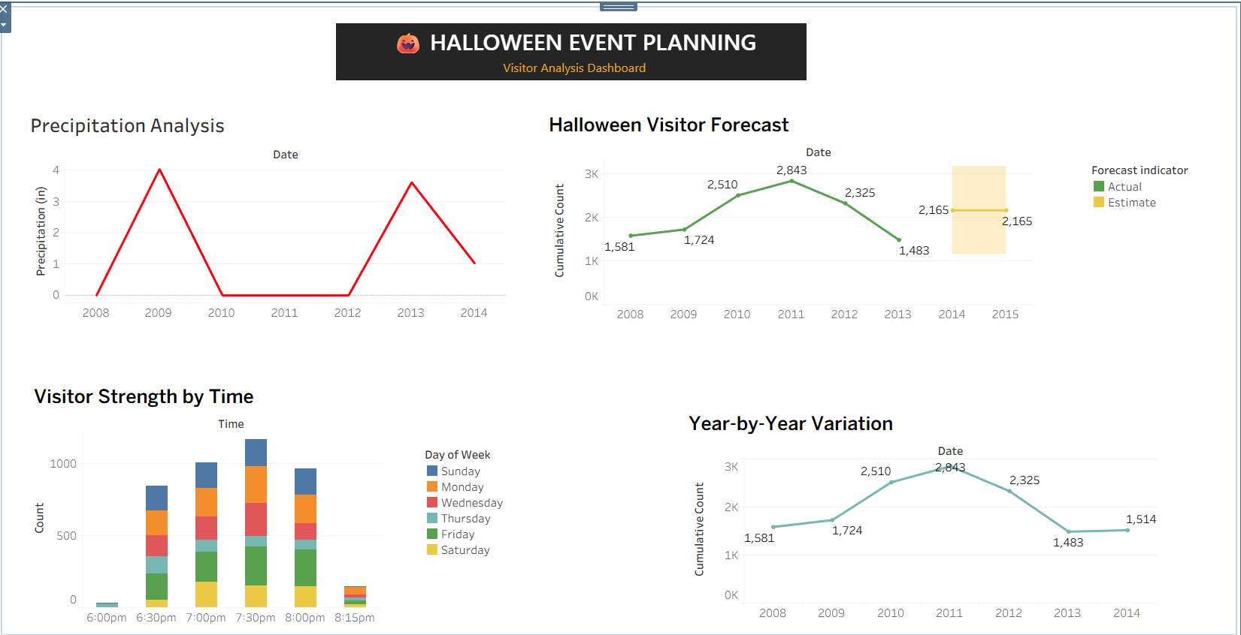

EX NO:07
DATE:
GLOBAL SUPERSTORE SALES TREND FORECASTING

AIM:
Use the global superstore 2016 to create a visualization predicting the precise future trends of the sale of the product over 6 quarters.

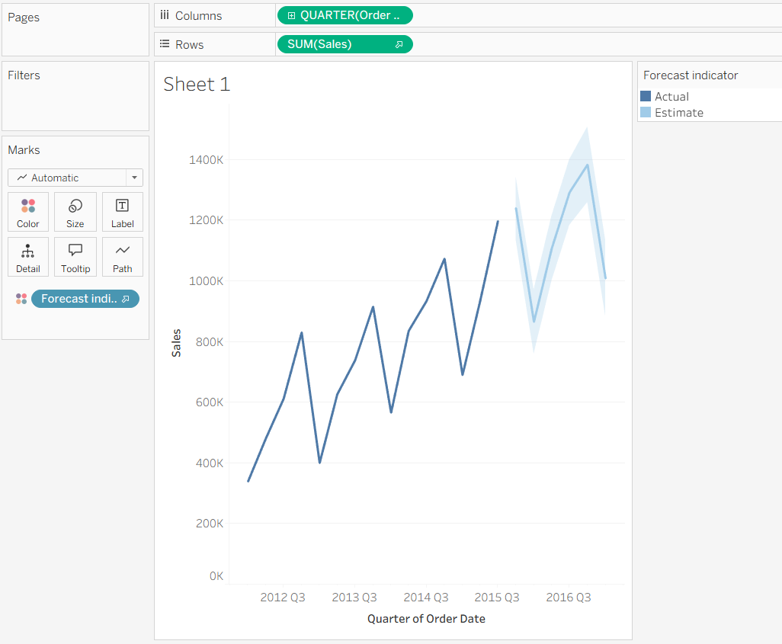

EX NO:08
DATE:
MOVIE RATINGS AND BUDGETS ANALYSIS

AIM:
Problem Statement: Domain: Entertainment Industry:
You have been approached as an analytics consultant by a movie reviews company. They are writing up an articles analyzing movie ratings by critics and audience as well as movie budgets for the years 2007 till 2011. You have been asked to perform the tasks: Refer the dataset: Movie-Ratings .csv

Task 1: Create a chart displaying Budget of Movies across different Genres over a period of time.
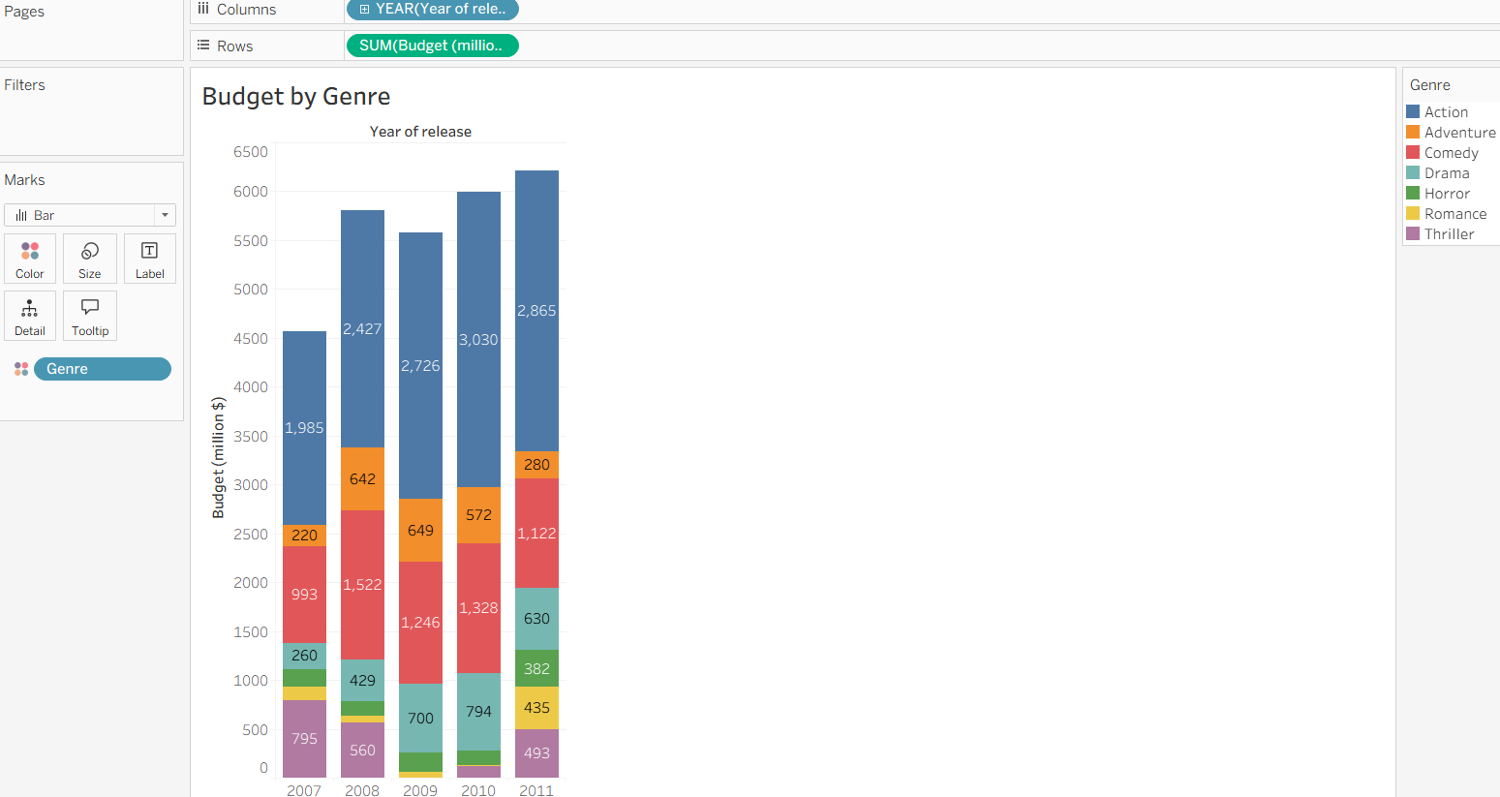
Task 2: Create a chart showing the correlation between audience and critic ratings
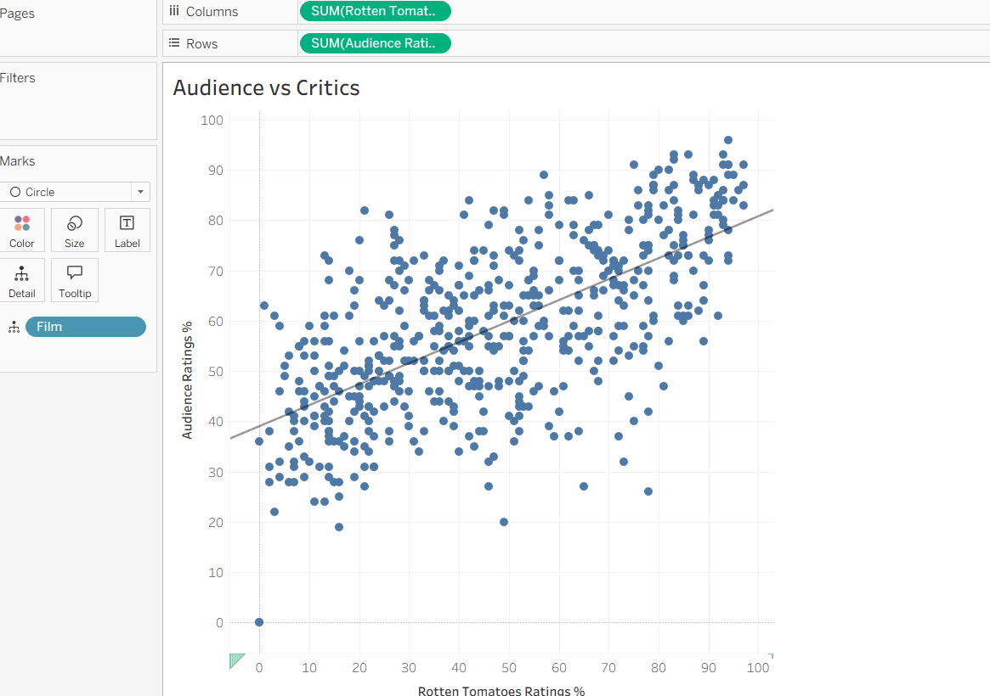
Task 3: Create a chart displaying the number of over released under every Genre over a period of time.
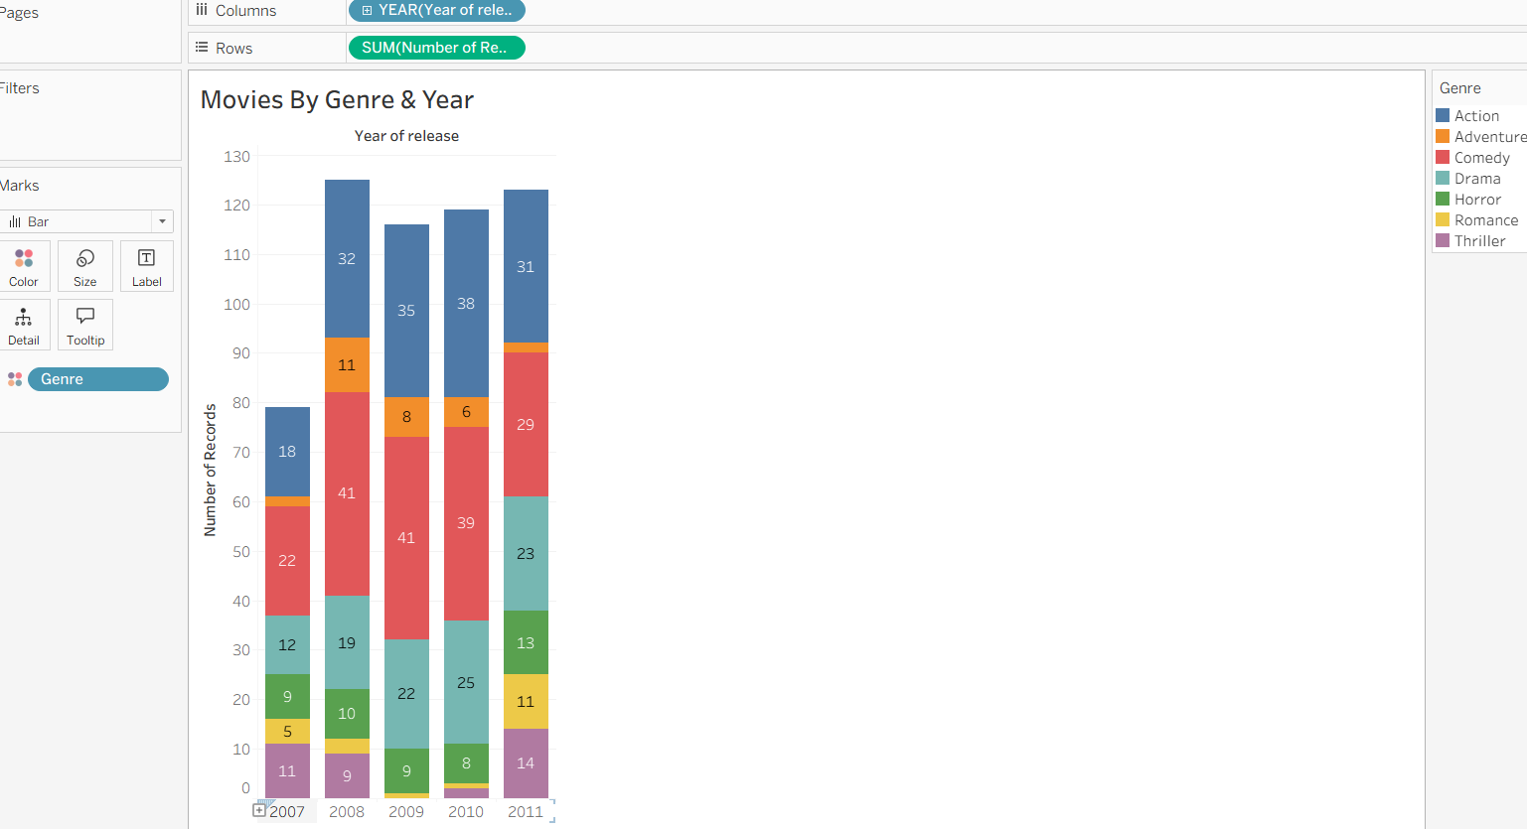
Task 4: Create a chart to visualize the comparison between the Ratings over a period of time.
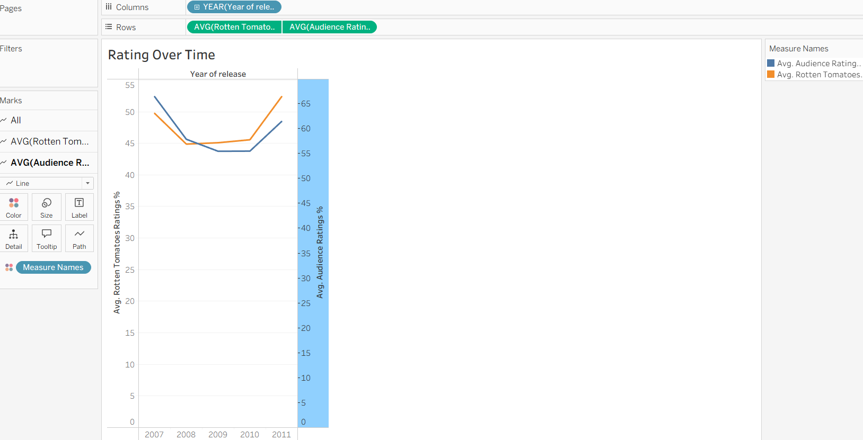
Task 5: Create a chart that will display the Budget of Top 3 Movies by both Audience and Critics rating. Also segregate the chart by Genre.
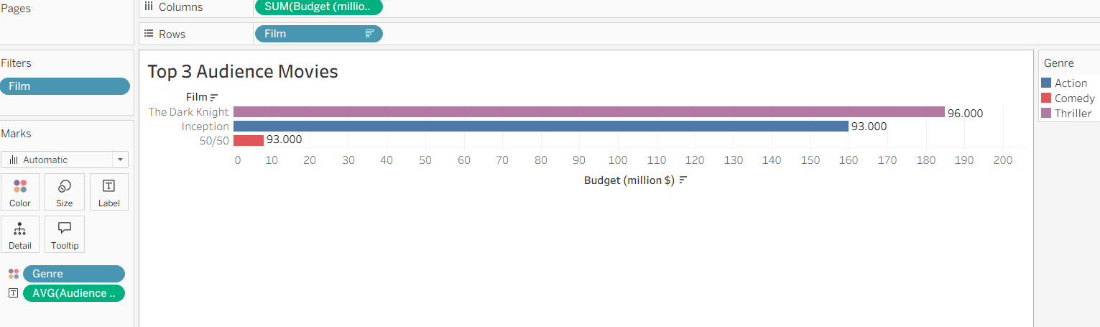
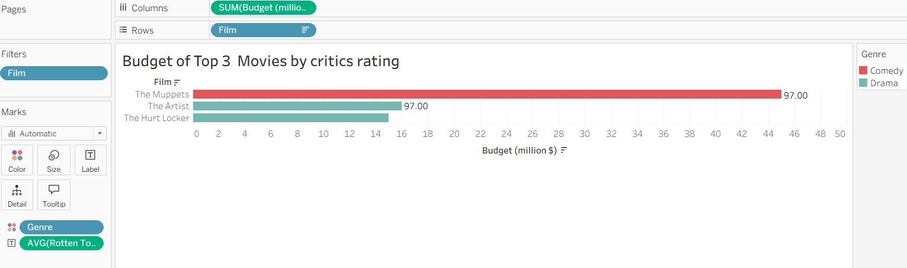
Task 6: Create a Dashboard, using the above charts.
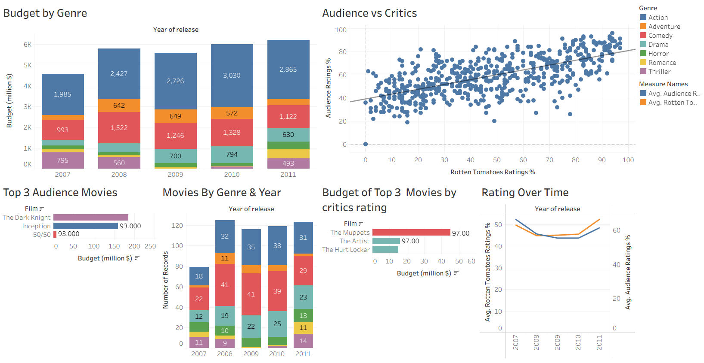

EX NO:09
DATE:
GLOBAL SUPERSTORE ADVANCED CHARTING

AIM:
Create the following chart: Using Global Superstore

- Bar in bar

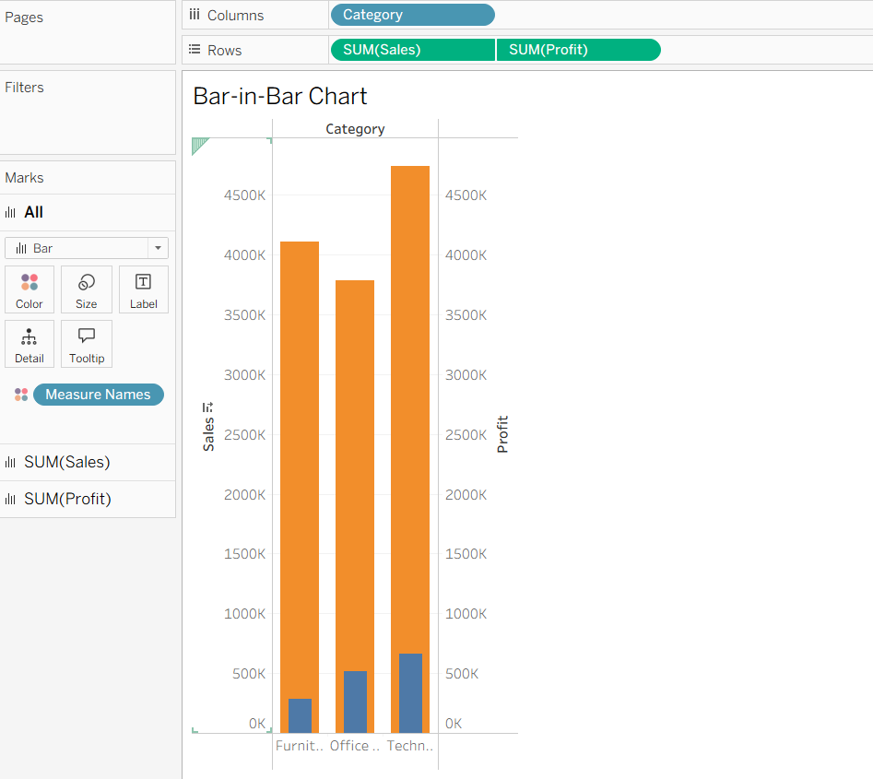

- Bullet

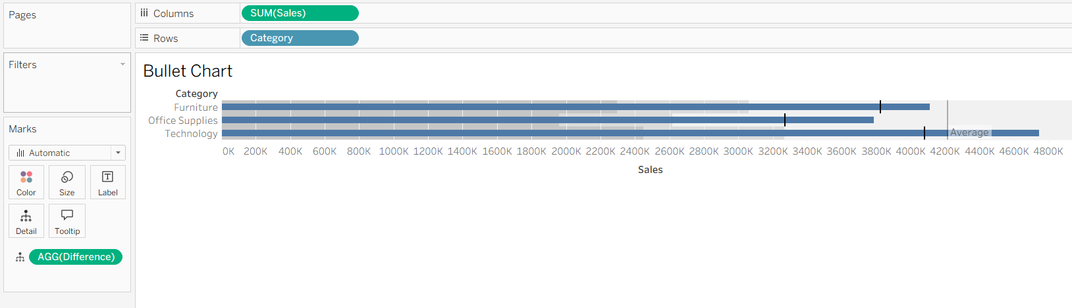

- Barbell

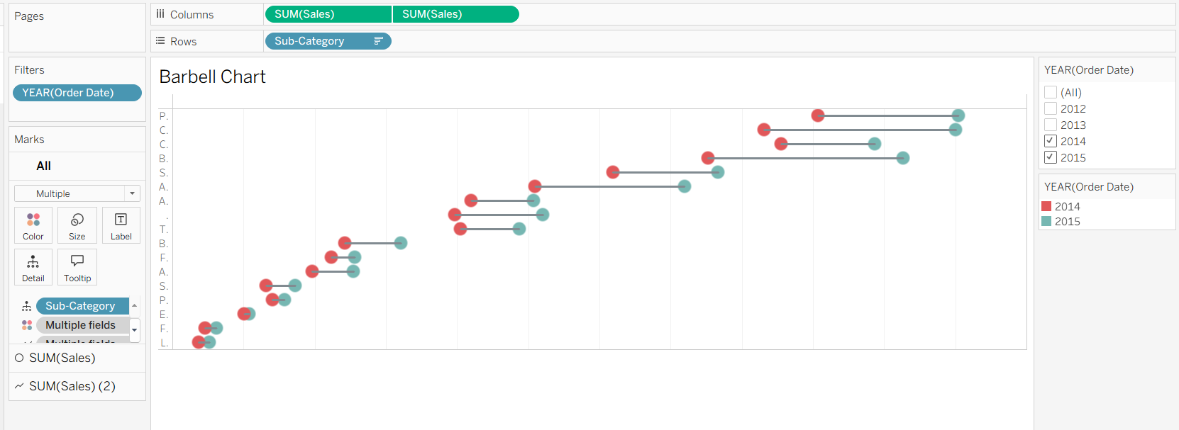

- Lollipop

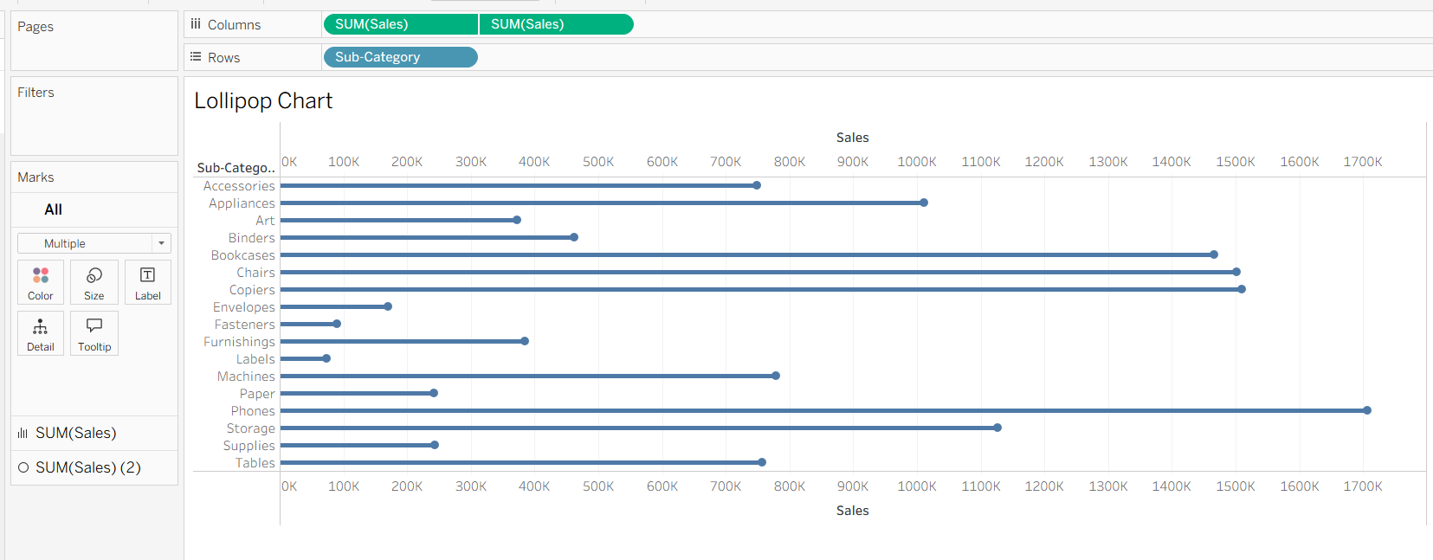

- Bump

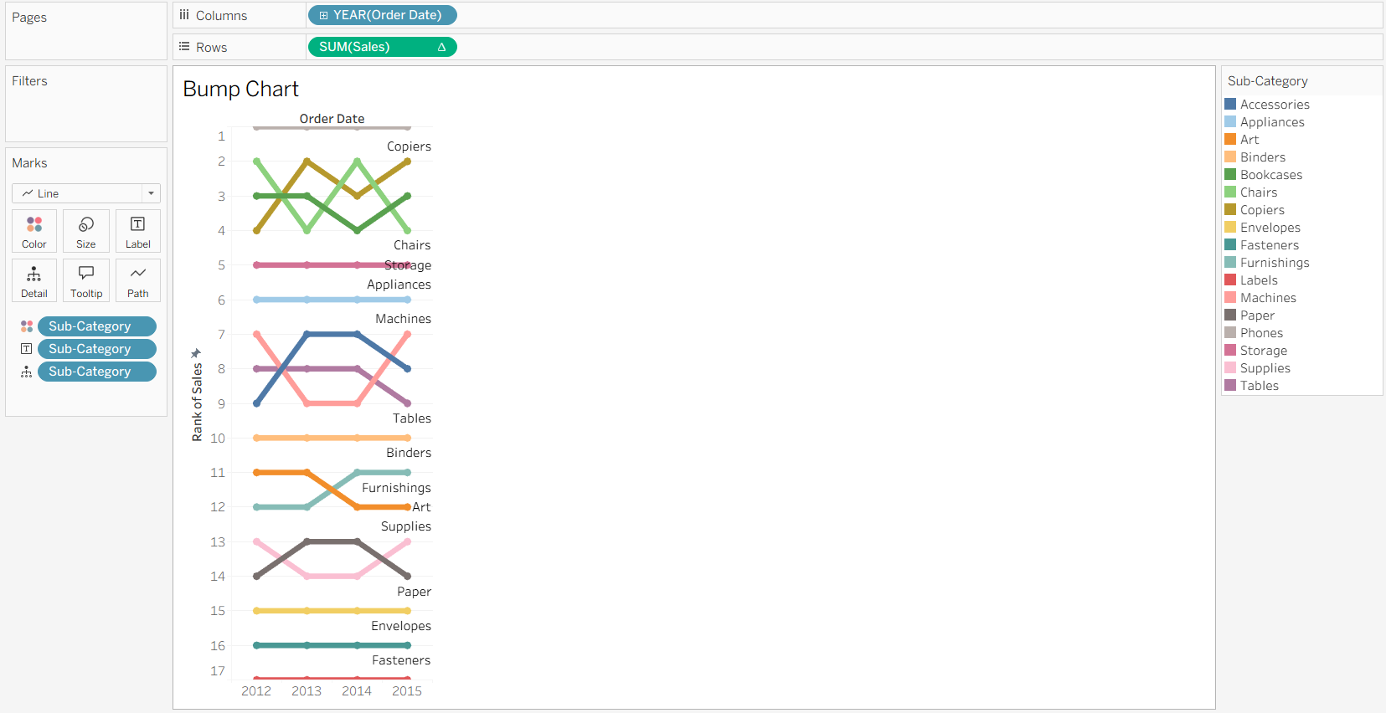

EX NO: 10
DATE:
ADVENTURE WORKS BI CASE STUDY

AIM:
Problem Statement: You are a BI Analyst in Green Eco Corp. The management has asked to analyze their data and create some attractive yet informative visualizations. (Refer the dataset: Adventure Works.csv)

Q1: Create a Bar in Bar chart on Sales and Profit by Country to compare these Measure against one another.
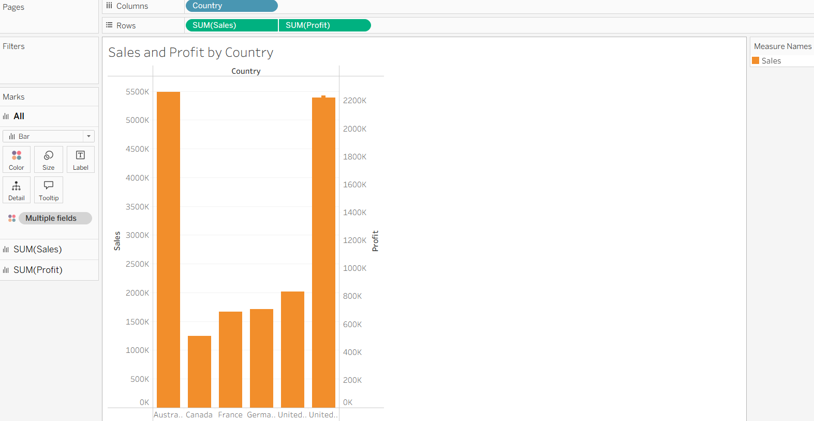

Q2: Create a Gantt chart that displays difference in Order quantity of each Category at Country Level. The duration of the chart should be on Week Continuous level.
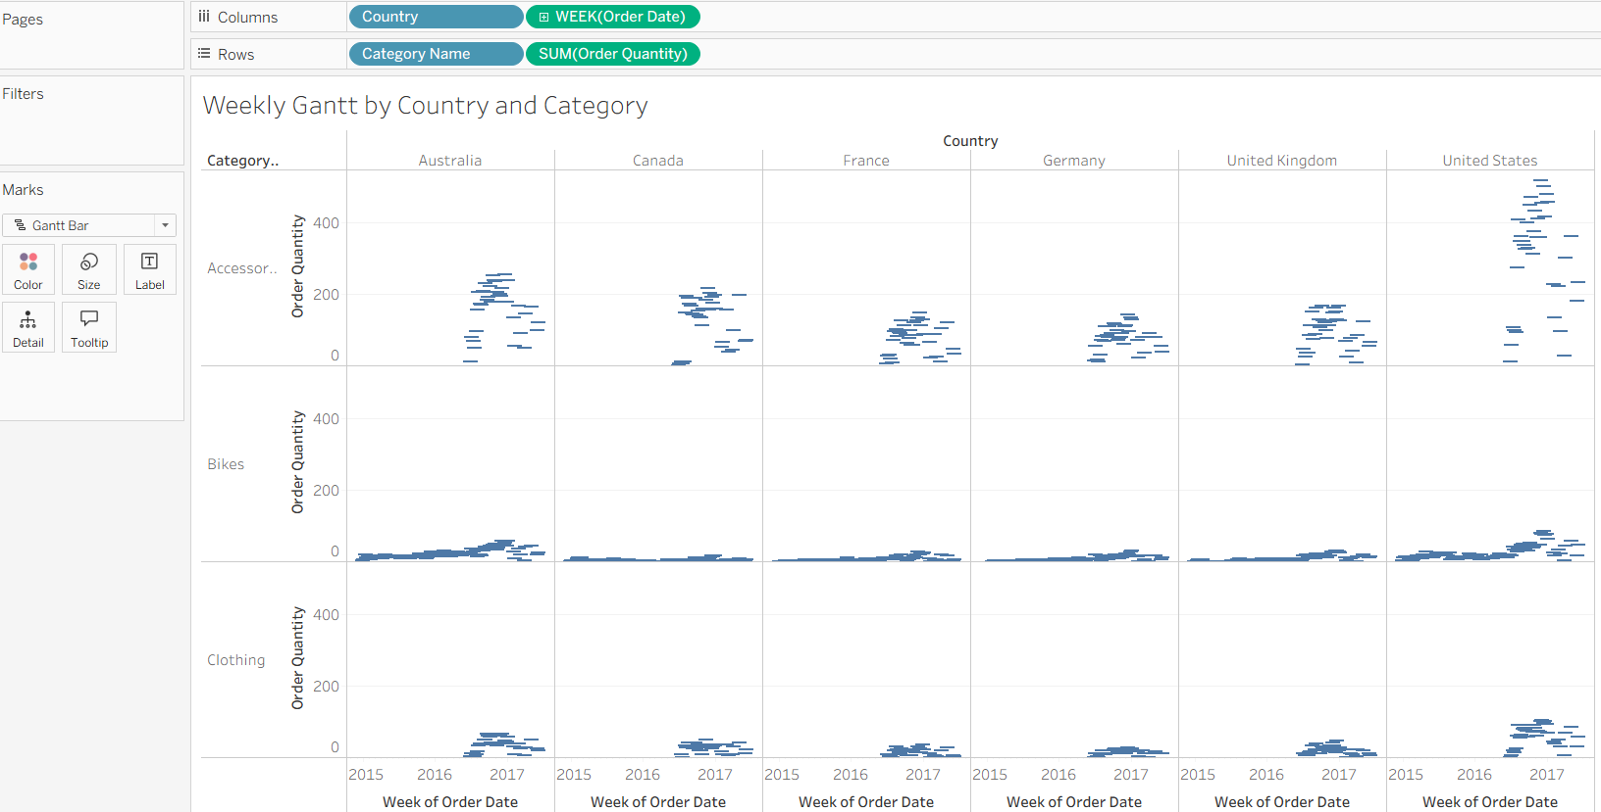

Q3: Create a Step and Jump line chart, displaying Cumulative Sum of Sales at Continuous Quarter level.
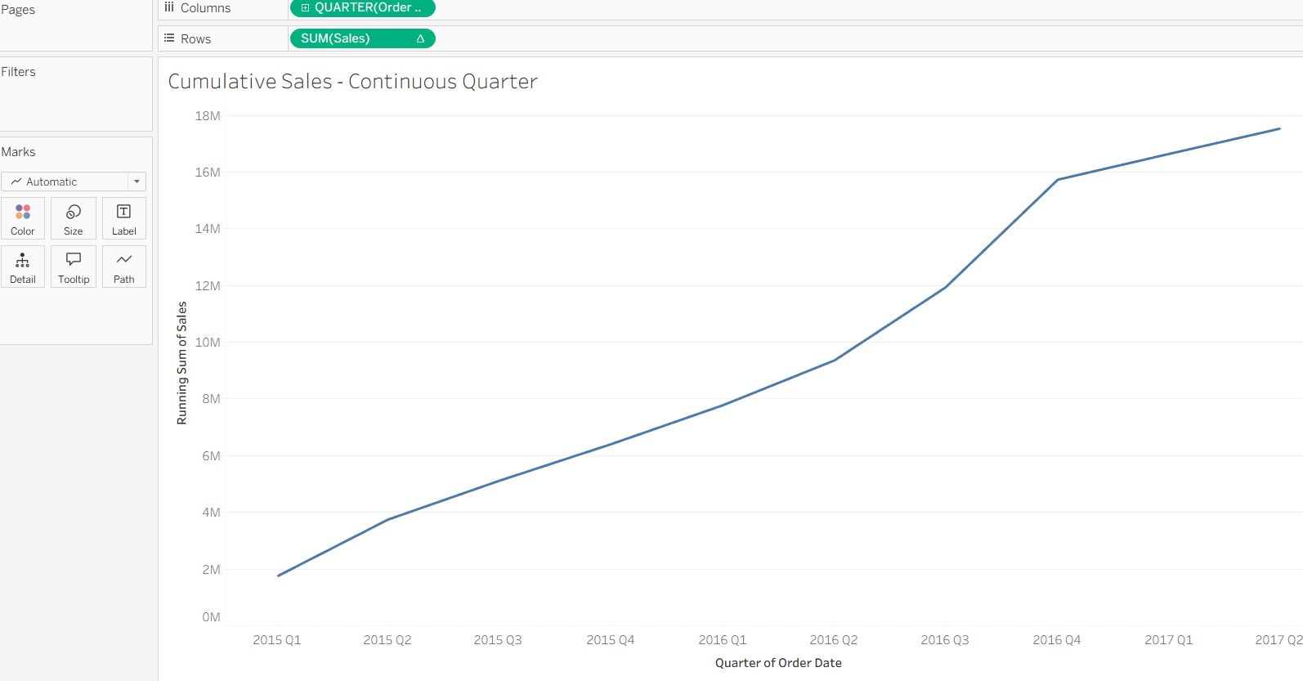

Q4: Create a Funnel chart by Profit and Region and find the trend.
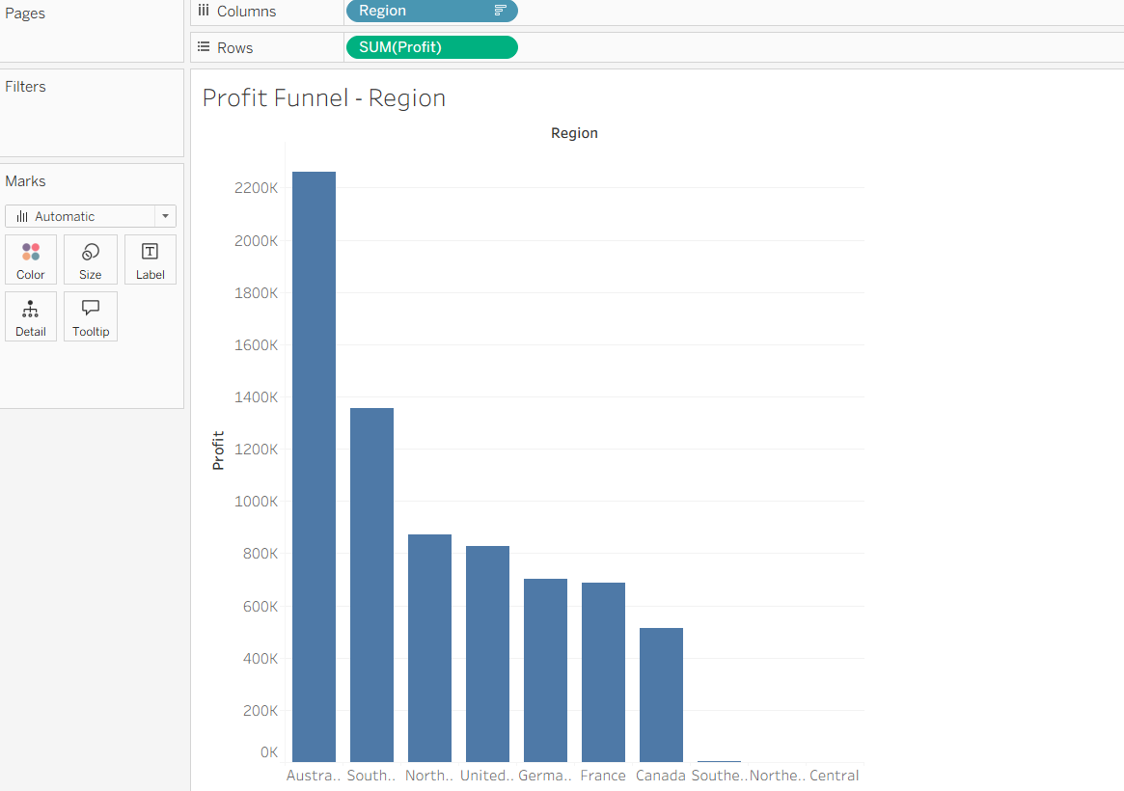

Q5: Create an Area Funnel chart by Order Quantity at Discrete Quarter level also reverse the chart in order to give it a proper funnel shape.
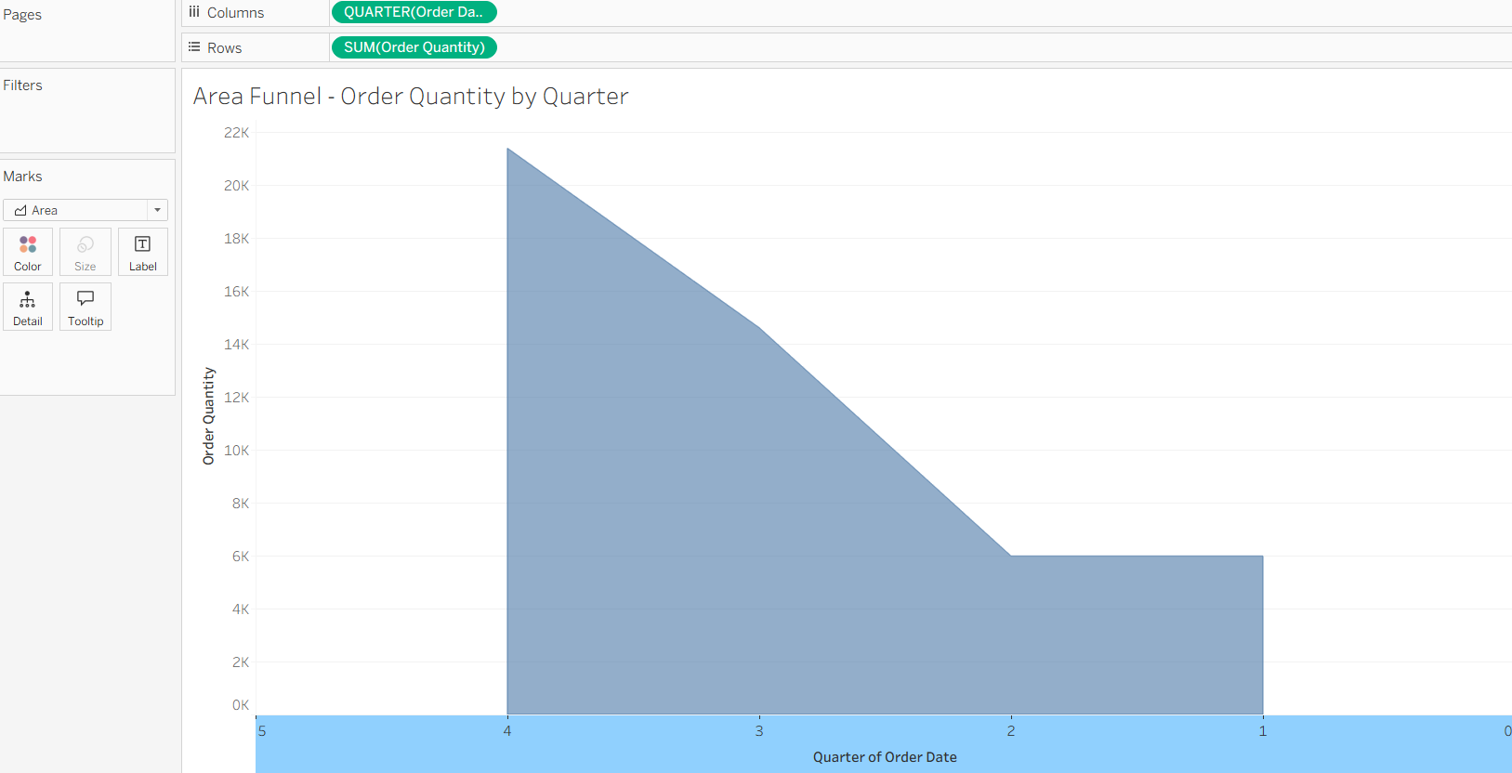

Q6: Create two Word Clouds in two separate sheets. The first chart should be on Sub-category where the Size and Color represent Profit and the second chart should be on Country where Size represents the Sales and Color represents the Country.
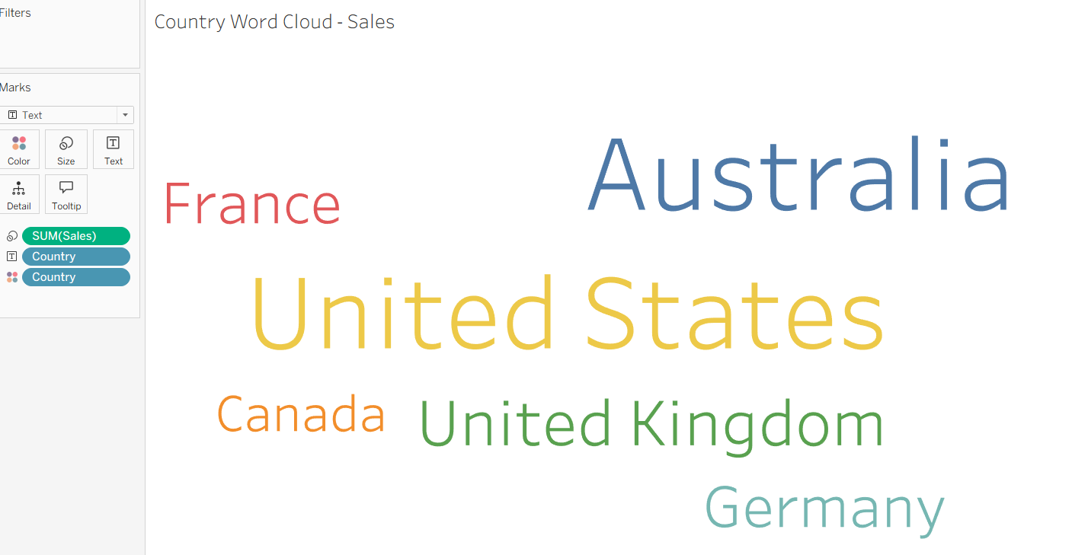
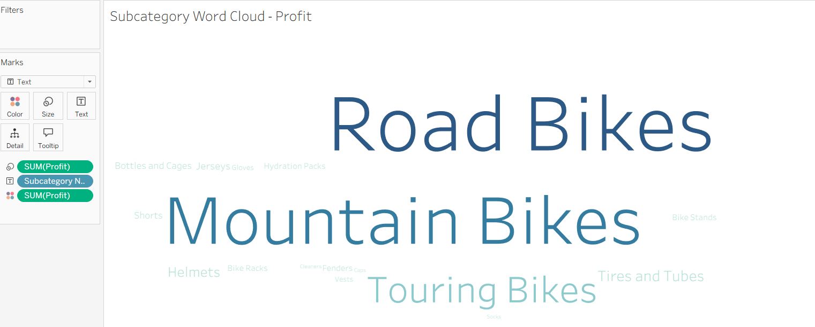

EX NO:11
DATE:
RAINFALL FORECAST REPORT

AIM:
Given weather data of past 34 years, use the data from 2011 to 2018 and create a report on rainfall forecast for the year 2019-20. (Use Weather Data 1984-2018.xlsx Dataset)

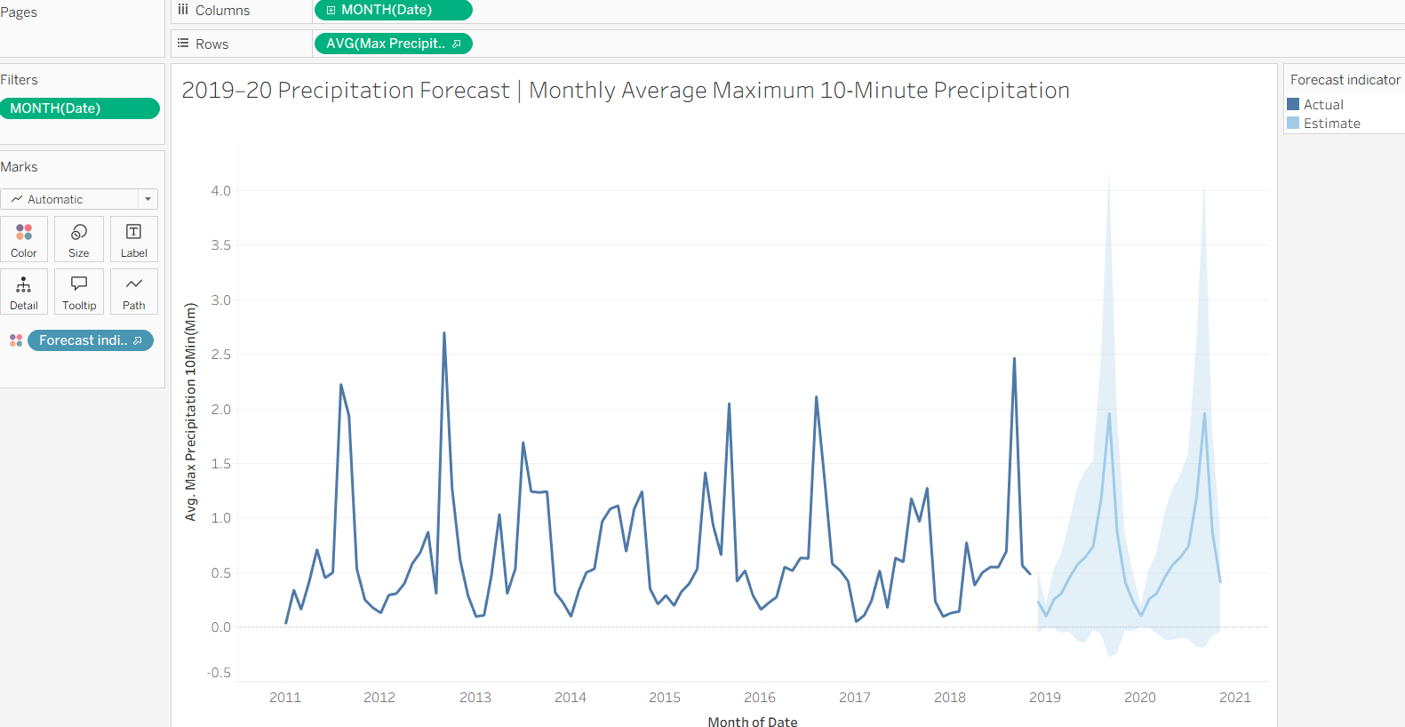

EX NO:12
DATE:

AFRICAN MOBILE DATA VISUALIZATION

AIM:
Using “African Mobile Data.xslx dataset”, visualize the profit of each country with their sales trend.
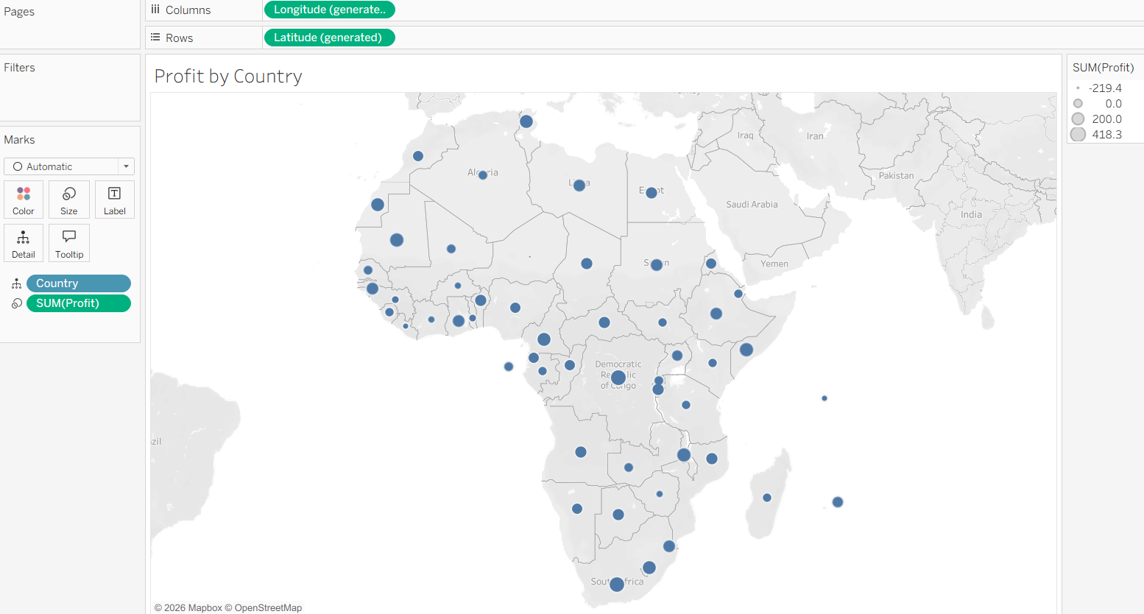

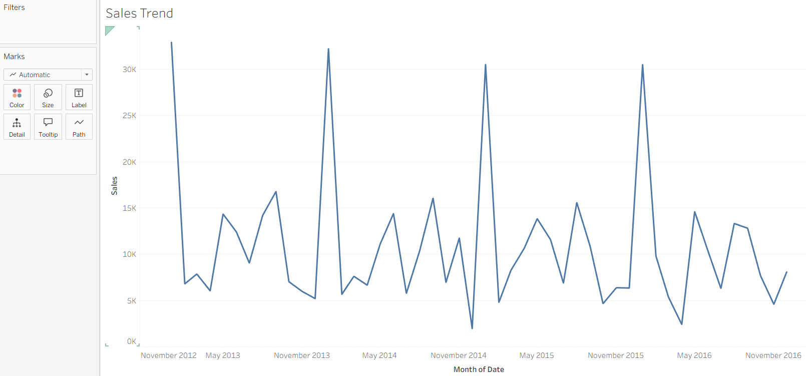

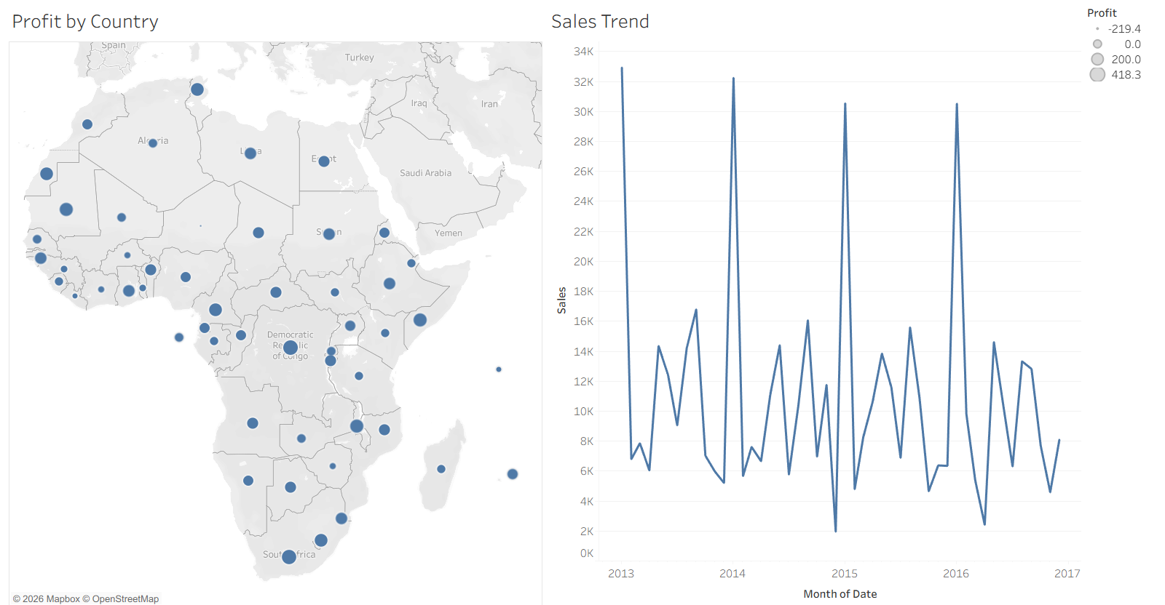

EX NO:13
DATE:

HIERARCHICAL DATA VISUALIZATION USING DRILL-DOWN

AIM:
Downloaded data –set (Sample Superstore) and perform following actions on the meta data.
•Build up hierarchy of (Country –State -City)
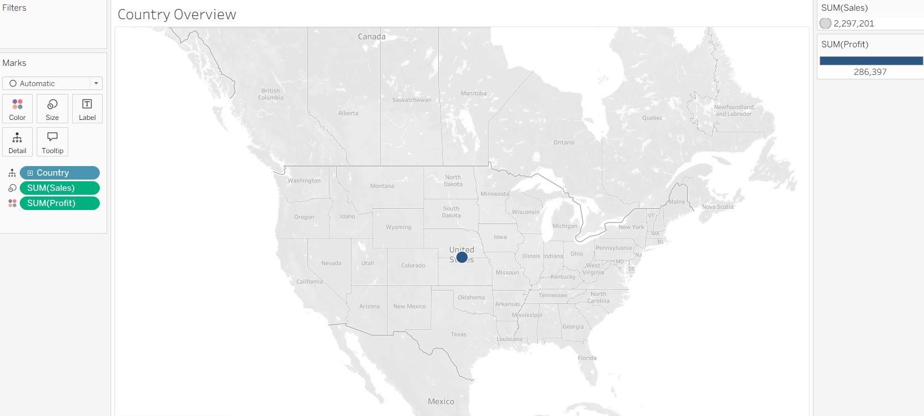
•Drill Down the country hierarchy
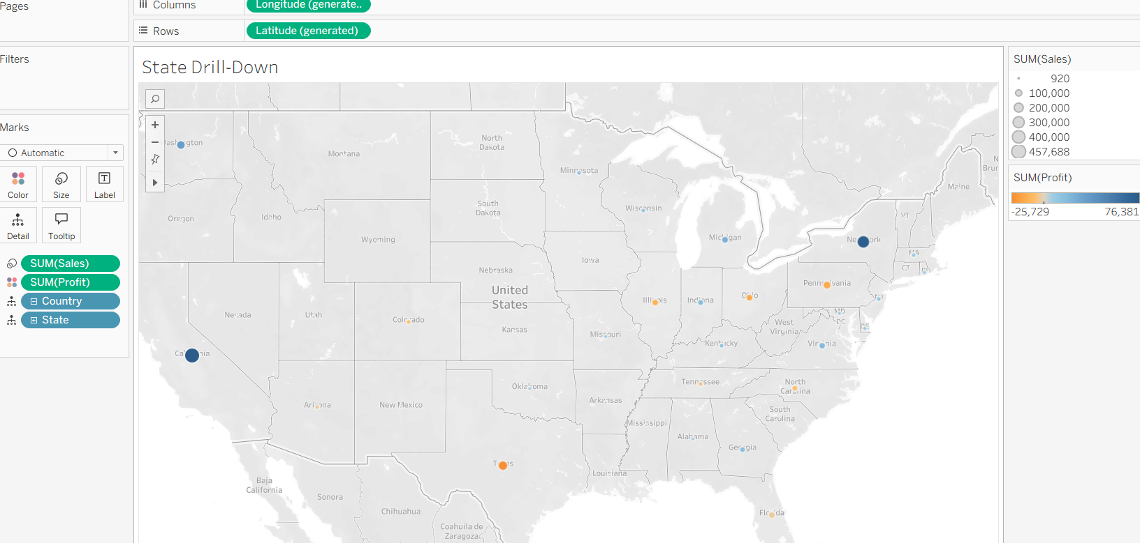
•Show the advantage of Changing Colors with the help of drill down concept
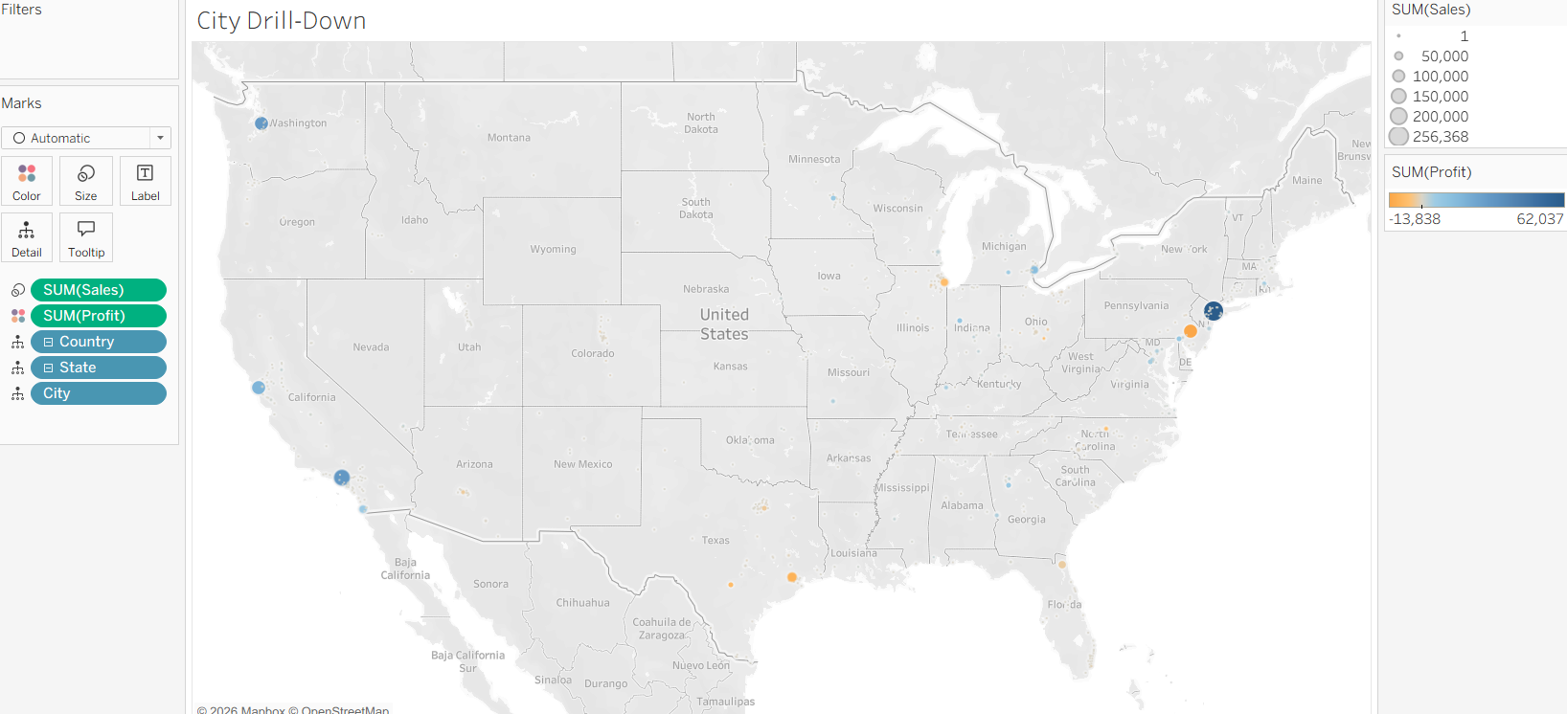

EX NO:14
DATE:

STUDENT ACADEMIC PERFORMANCE SEGMENTATION

AIM:
Using the “Student Academic Data.xlsx”, create segments of Good, Average and Bad performance in “Math test” and “Writing test”.

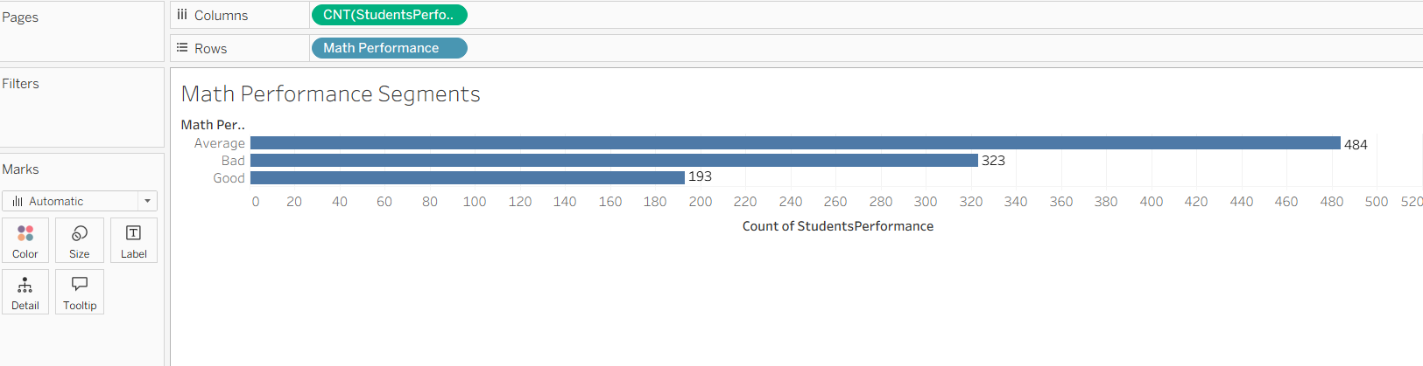

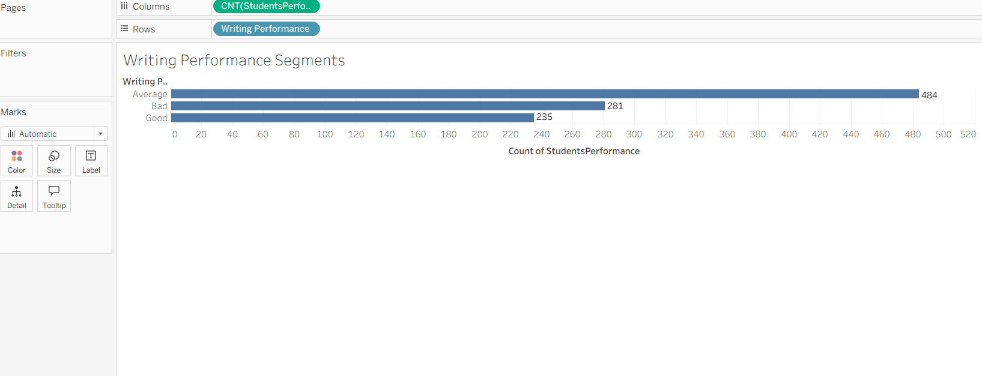

EX NO:15
DATE:

PARK VISITING TREND STACKED BAR CHART

AIM:
Using “Park Visiting trend.csv” dataset, build a stacked bar chart and label it at the end of the bar.



